Fall 2017 Upward Bound Classic News

**October 10, 2017**





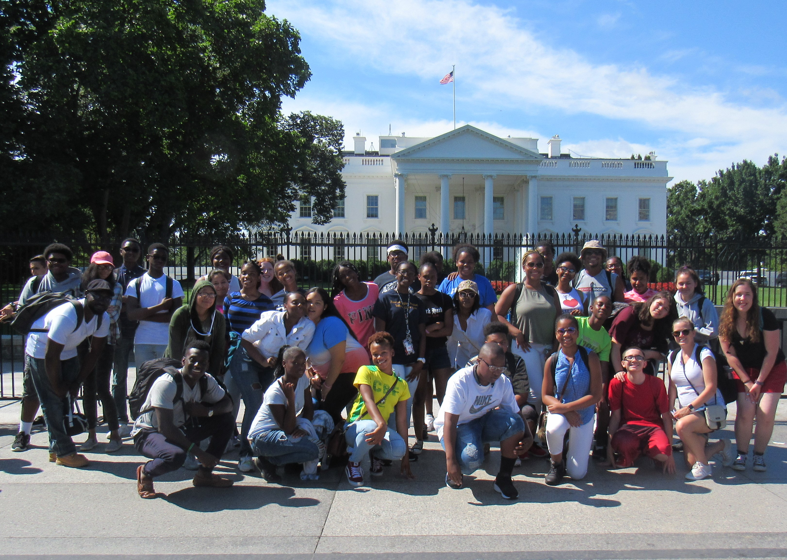

FAREWELL to Mrs. Rigdon

As overjoyed as we were with the good news of our grant application approval, we were equally distressed to learn that our Coordinator, Mrs. Brittany Rigdon was leaving us to pursue other opportunities.**N**ot only will the students in those communities and schools who have demonstrated ongoing need will miss her caring spirit and support, but we will miss her significant contributions to educational access and attainment.

To Mrs. Rigdon, thank you, for bringing her positive attitude to work every day. Projects become easier to execute, changes become easier to implement and problems become easier to solve. A perfect employee is the one who inspires her boss as much as her boss inspires her. Thanks for being my inspiration.

 

# Available Services for fall 2017

**Tutoring:**

We are starting our weekly tutoring program. Tutoring is on Monday through Thursday, from 4pm to 7pm. Tutoring is available for Math, English, Science, French and Chemistry.

MANDATORY TUTORING FOR STUDENTS WITH LOW GRADES

All students whose cumulative GPA has fallen below a 2.3 or are failing any subject are required to attend tutoring every week. Tutoring is not a punishment, but a support to assist you in understanding the material so you can succeed. Intervention is the key is improving your grades.  If you need tutoring, please contact me or the tutors directly, to schedule individual appointments.   I am also working on an online tutoring service, which should be available shortly.

Nana Marfo:  Chemistry     [Nana@udel.edu](mailto:Nana@udel.edu)

Taurance Chisholm:  Algebra and Science                      [tchizjr@udel.edu](mailto:tchizjr@udel.edu)

Larissa Thermidor:   English and French                   [lsthermid@udel.edu](mailto:lsthermid@udel.edu)

Jacob Verbanas: Advanced Math [jverb@udel.edu](mailto:jverb@udel.edu)

UBC EXPANDS PARTNERSHIPS

We formed an exciting partnership with OnTrack this academic year.  OnTrack to Post-Secondary Education is an online e-learning college and career readiness program for high school age students to understand the process of achieving post-secondary education. OnTrack provides students with a step-by-step guide on the college process.

**OnTrack also provides 9th-12th grade students with the knowledge to complete their educational experience through weekly grade-specific video modules. Using the prescribed OnTrack curriculum, students are prepared to apply to post-secondary schools, gain acceptance, and receive financial aid to those schools**

**. Sign-up instructions:**

1. **Before you sign up, you should watch this walk-through video, which explains how to use OnTrack:**
2. [**https://ontrack.hosted.panopto.com/Panopto/Pages/Viewer.aspx?id=477ba6a6-04e3-4cea-9901-6f10944e528b**](https://ontrack.hosted.panopto.com/Panopto/Pages/Viewer.aspx?id=477ba6a6-04e3-4cea-9901-6f10944e528b)**Students will then go to** [**ontrackpse.com**](http://ontrackpse.com) **and click the Sign Up button.**
3. **To sign up, you will need an Access Code, which you will put on the first page of their sign up. The Access Code for our program is: UDUB1**
4. **The sign-up process is 3 quick pages and the issues you might face on them are covered in the document I linked to earlier.**
5. **I’ve attached document that shows you how to turn off the pop-up blocker. That’s often the number one issue students face after they sign up. (Please refer to the pop-up blocker document)**



**Stats: UBC Summer Success Pays Off**

### **Orientation & the First Day**

* 98% agree that orientation prepared them for what to expect this summer
* 92% agree that first-day activities gave them needed information and helped them better understand how to care for and respect themselves and others

**Attitude & Personal Growth**

* 100% are committed to behaving in a way that will help them achieve their goals
* 97% experienced success this summer that made them feel good about themselves
* 98% feel more positive about their future because of being in UBC

**Social/Cultural**

* 8% believe living in the dorm this summer will help them be more comfortable living away from home in their freshman college year
* 50% of the 68% of Scholars who lost behavior points said they learned from it; 32% did not lose any points
* 95% think we should keep doing the end-of-summer cultural trip

**Academic**

* An average 95% of Scholars learned something they didn’t know before in Summer Academy classes
* 98% believe that things they learned this summer will help them pass their school classes in the 2017-18 academic year

**Overall**

* 97% felt that the summer trip was a good incentive to work toward
* 93% felt that being in Summer Academy was helpful for them

Dr. John France., Director 302-831-4103 [Jfrance@udel.edu](mailto:Jfrance@udel.edu)

Tiffany Sewell., Program Assistant [sewellt@udel.edu](mailto:sewellt@udel.edu)

**Cont’s**

SAT with Khan Academy:

We also partnered with Khan Academy, which is a free online SAT prep services.  Khan Academy and College Board has formed a partnership to provide a free, personalized study plan to prepare under representative students to successfully score higher on the SAT.   It is a very easy and simple process.  You can create an account at https://www.khanacademy.org/sat and begin the online practice and tutorial.

Khan Academy offers practice exercises, instructional videos, and a personalized learning dashboard that empower learners to study at their own pace in and outside of the classroom. They tackle math, science, computer programming, history, art history, economics, and more. Their math missions guide learners from kindergarten to calculus using state-of-the-art, adaptive technology that identifies strengths and learning gaps. They’ve also partnered with institutions like NASA, The Museum of Modern Art, The California Academy of Sciences, and MIT to offer specialized content.  It is very useful. We encourage all program participants to use it.

New Delaware Scholarship Compendium Released:

The scholarship compendium is a must read for senior and underclassmen families to see what financial opportunities are available for college.  [http://scholarships.delawaregoestocollege.org/wp-content/uploads/2017/09/2017-2018-Delaware-Scholarship-Compendium-0905.pdf](https://teensharp.us3.list-manage.com/track/click?u=56bff1e1c7a95a9f23d3a4328&id=cc093ca7da&e=c834384f4f)

**Post 2017 summer Academy Report**

|  |  |  |  |  |
| --- | --- | --- | --- | --- |
| Courses | Pre-Test | Post Test | Average Increase | Sample Group Numbers |
| Math Averages | 55% F | 92.3% B+ | 67.82% Increase | 41 |
| English | 82% C | 92% B+ | 12.2% Increase | 43 |
| Spanish | 47% F | 81% C | 72.34% Increase | 27 |
| Science | 43% F | 80% C- | 86.05% Increase | 15 |

The data above shows the increase between participant numbers in the 2017 Summer Academy compared to those in 2016, an extraordinary increase of 215.38%. Not only did the UBC Staff recruit a higher number of participants but they were also successful in retaining new participants throughout the 6-week program.

The one student who dropped did so after the week one progress report showed that she was failing all courses due to lack of course and homework completion. She decided to drop from the program by not showing up; a follow up phone call was made to her mother by the program coordinator to try and encourage her to continue with added resources and support. She declined the offer of support and will not be counted in program numbers due to not completing a full 2 weeks in the program.