New Castle County Mounted Patrol Unit
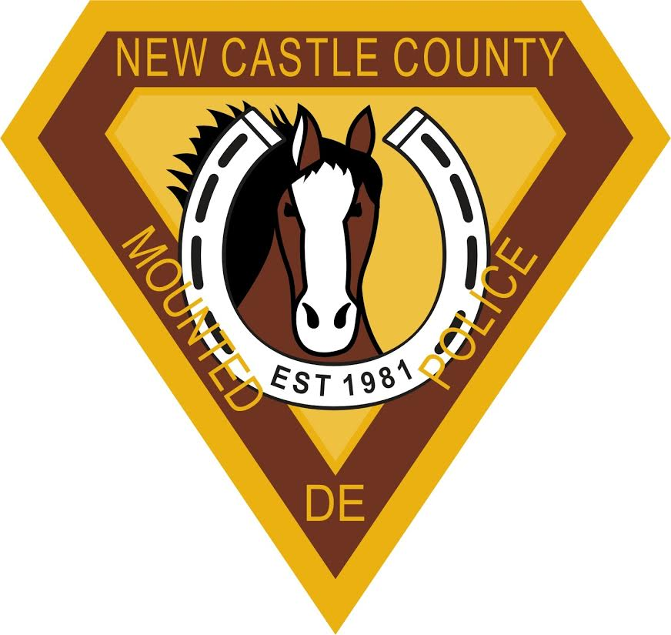
is offering a

Fall 2014 Equine Internship
Carousel Park Equestrian Center
3700 Limestone Rd Wilmington, DE 19807

The New Castle County (NCC) Mounted Patrol Unit owns and utilizes 10 draft and draft-cross horses for police work. The unit and horses are based at the Carousel Park Equestrian Center, located approximately 20 minutes north of the University of Delaware. Additionally, the NCC Mounted Patrol Unit has two Clydesdale colts that are in training to be future police mounts.

There is the possibility for 2 interns to fill this internship. Your internship will be cover the daily care, maintenance and training of these newly acquired colts, as well as daily care and exercising of police horses. Through this internship, you will learn and improve upon a variety of general horsemanship skills as well as skills that are more specific to that of the mounted patrol unit. Your responsibilities may also include barn management such as feeding, grooming, tacking horses, bathing and mucking stalls. The ideal intern(s) will have the experience to assist in riding and exercising horses that have already completed their police training.

The projected work schedule is generally Monday through Friday 9:00 a.m. to 12:00 p.m. You will also maintain a daily log for each of the foals, and will work with other members of Law Enforcement as well as civilian employees. The mounted unit will be on the grounds of Carousel Park from October through December. This is a 4-6 week unpaid internship depending on your start date.

The Carousel Park Equestrian Center is situated on 216 acres with well-groomed riding trails, ponds and a cross country course. The center is equipped with an indoor and outdoor riding ring for all weather riding. For more information see: http://www.carouselparkequestrian.com/

The successful applicant will be required to sign a waiver of liability assuming all responsibility for injury. They will also be subject to a limited background check.

Requirements:
  - Live locally and have reliable transportation to and from the Equestrian Center
  - Ability to begin internship by October 1, 2014
  - A desire to work hard and learn about the care and training of mounted police horses
  - Open to new ideas and practices for managing horses
  - Some equine experience required, riding experience is preferred but not mandatory
  - A full report summarizing your experiences at the end of the internship

To apply: Email the following in a WORD document to Nemeclm@udel.edu by September 15th
- Send a 1-page resume AND
- a 1-page statement that includes:
  - A short summary of your equine experience, both handling and riding
  - How the internship will contribute to your professional development
  - How you will contribute to the internship program

Note: In order for this internship to meet with DLE requirement, students must register for ANFS 464. You can speak to an academic advisor in the Department of Animal and Food Sciences about ANFS 464. However, if you do not need DLE or do not want “credit” for the experience, you can just include the experience in your professional resume.

