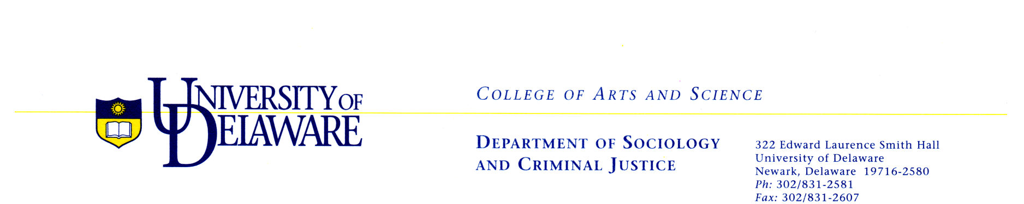

CALL FOR ABSTRACTS
10th Annual Graduate Student Conference
University of Delaware
Friday, February 10th, 2017

“Social Inequalities: Methodological Implications”
An Interdisciplinary Social Science Collaboration

Featured Keynote Speaker:
Annette Lareau, Ph.D., University of Pennsylvania

Abstract Submission Deadline: November 25th, 2016
Please submit your abstract here.

The Department of Sociology and Criminal Justice at the University of Delaware invites you to submit an abstract for our 10th Annual Graduate Student Conference. This year we welcome projects related to individual, interactional, and institutional forms of social inequalities. While empirical work will be considered, we wish to highlight papers with a strong methodological focus. We ask applicants to think critically about their methodological decisions. Some suggested questions include:

- How have your own social locations influenced your (in)ability to gain access to the field? How did you maintain relationships with participants during and after data collection?
- How did intersectionality influence your work? How did you choose which social identity factors to incorporate into your analysis?
- How do you reconcile methodological limitations within your work? How might your work benefit from other methodological approaches to your research questions? Mixed methods?
- How does your epistemological stance shape or influence your chosen methodologies?

We are now accepting abstracts (450-550 words) from graduate and undergraduate students for papers addressing social inequalities and the methodological concerns surrounding the study of these issues. Abstracts should be submitted through the online portal linked above. Acceptance decisions will be made by mid-December. Accepted presenters will need to provide copies of their final papers by January 20th, 2017 to Bri VanArsdale at blv@udel.edu.

Questions can be directed to conference co-chairs: Em Rowe at erowe@udel.edu or Bri VanArsdale at blv@udel.edu.

