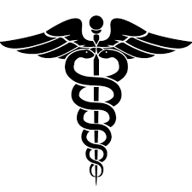  The Anatomy |  | Making Doctors  University of Delaware  Matt Navarro and Umma Fatema  November 5, 2015
What’s in the News?  Womb transplants open doors to an artificial future  By Kristine Fagtanac  We’ve all heard of kidney transplants and heart transplants, but how many of us have ever thought of transplanting an entire womb? By the end of September this year, 10 women in the UK had been given approval by the Health Research Authority to go through the operation. The team of doctors, led by Dr. Smith, will be taking the donor wombs from brain-dead (though still living) patients. The procedure is to be performed by 12 doctors and it is estimated that the transplant operation will take around 6 hours. To reduce the risk of the donated womb being rejected, the women will then take immunosuppressant drugs for 12 months after the operation and again during their pregnancy. Unfortunately, the babies born from these wombs will not be birthed traditionally, and the women will have a cesarean section performed on them to reduce damage to the transplanted womb.  This is not the first time that womb transplants have appeared on the news radar. In 2014, a Swedish woman gave birth to the first ever womb transplant baby. It was this phenomenon that inspired the current ongoing project in the UK. Before the project can commence, £500,000 ($760,000) must be raised by Dr. Smith and his team. However, if the project meets its goals, the first few babies born from a womb transplant in the UK could come as early as 2017.  Ethical implications aside, the commercialization of this operation could open many new doors in the scientific and medical fields. More specifically, ectogenesis could soon become a reality. If viable fetuses can grow in a transplanted womb, then who is to say that they can’t grow in an artificial womb? Or maybe even in conditions outside of a biological organ? That is not to say that we can just start growing babies out of petri dishes, but at this rate, the future holds a very real possibility of this becoming a reality.  Doctor of the Day  Dr. Charles Richard Drew was an African American physician, surgeon and researcher. He was born in Washington D.C in 1904. Throughout his career, he focused his studies on blood transfusions, and was able to devise more effective methods of blood storage. Dr. Drew’s research was pivotal in running safe and effective blood banks during the World War II. His research ultimately led to thousands of soldiers and civilians being prevented from diseases spread by blood transfusion. Dr. Drew was also a strong advocate for racial equality in blood transfusions; for example, when the U.S. military wanted to separate blood donated by African Americans during the WWII, he spoke out and proved that there was no biological difference between African American blood and Caucasian blood. Dr. Drew passed away when he was only 45 years old, but his work led to the advancement of many modern medical procedures.  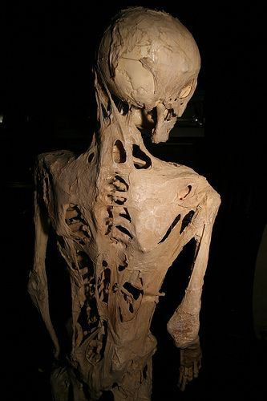  Bone can do much more harm than good…  Fibrodysplasia ossificans progressiva (FOP) is an extremely rare autosomal dominant disorder of the connective tissue. FOP originates from a mutation that causes fibrous tissues such as muscles, tendons and ligaments to turn into bones, which can occur spontaneously or when they are damaged. The most well known FOP case is that of Harry Eastlack. By his 40th birthday, Eastlack’s body had completely ossified (turned into bones). He wished to donate his body to science in hopes for a cure, and his skeleton is currently located in the Mutter Museum of Philadelphia. Although significant progress has been made to learn more about this disease, there is still no cure for it.  Umma’s Random Molecule of the Week is…  Glutamate!!  Glutamate is an excitatory neurotransmitter that is involved with learning and memory. It was first isolated by 1908 Japanese researcher Kikuane Ikeda. It is an amino acid neurotransmitter that has shown ties to Alzheimer’s Disease, ALS, and Fibromyalgia. |  | What Nerds Laugh About...  What did the chemical agent say?  My name is Bond, Ionic Bond. Taken, not shared.  MCAT Question of the Week:  According to scientists Oparin and Haldane, which of the following gases were present in the primitive atmosphere?  A. CH₄, NH₃, H₂, H₂O  B. CO₂, NH₃, H₂, H₂O  C. N₂, O₂, H₂, H₂O  D. CH₄, NH₃, O₂, H₂O  Answer: Turn over the page to find out!  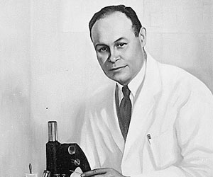  A Quick Study Tip:  Make a daily schedule! Plan what you will do in between classes, and draw your schedule into a planner or calendar. Setting rewards for completing you study goals will make studying that much more appealing. Add study breaks into your schedule and try to do something that relaxes you during those breaks.  (MCAT QotW answer: A)  Could the Philly be your future home?  Perelman School of Medicine  This is the medical school of University of Pennsylvania. It is the oldest and one of the most prestigious medical schools in America. Students have the opportunity to earn M.D., Ph.D., M.D.-Ph.D., master’s, M.D.-master’s, or post-doctoral degrees. This college is a major center for biomedical research and constantly ranks among the highest recipient of National Institute of Health awards. The faculty-student ratio at University of Pennsylvania is 4.3:1. Every year 655 students are enrolled.

