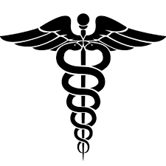  The Anatomy |  | Making Doctors  University of Delaware  Matt Navarro and Umma Fatema  September 16, 2015
Welcome!  Hello Blue Hens, and welcome to Making Doctors’ “The Anatomy”! Our aim is to bring you some interesting facts, stories, and information about the medical world. Through “The Anatomy,” Making Doctors works day and night to bring you valuable information and tips about medical schools and the healthcare field. Enjoy!!  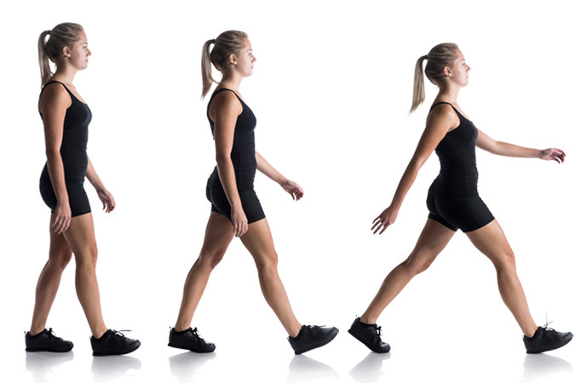  What’s in the News...  Lazy Bones? More like Lazy Brains…  Scientists recently explored the relationship between movement and energy expenditure, Reporting in the journal Current Biology, Dr Maxwell Donelan and his team attached robotic suits to nine participants in an effort to observe energy expenditure under changing conditions. These robotic suits made it more difficult to walk, so as participants continued to move around, their gait changed. In measuring energy expenditure throughout this time, the scientists found that after an initial rise due to increased resistance, the body saved more energy as the participants continued to walk, meaning that the participant adapted to a more energy-efficient method of walking. This means that the brain and nervous system were able to recognize the increased stress and adapt to it, in order to reduce energy output. Dr. Donelan writes, “Our collective findings indicate that energetic cost is not just an outcome of movement, but also plays a central role in continuously shaping it.” So, don’t feel bad next time you choose watch tv instead of going for a run; after all, it’s just your nervous system trying to help out.  Doctor of the Day  Rene Laennec, a French Physician born in 1781, made a revolutionary discovery in the medical field when he invented the stethoscope. Before his time, the only way physicians could hear the sounds of the heart was to place an ear up to the patient’s chest, which quite often resulted in inaccurate readings of heart rate, as sounds were unclear. The stethoscope ultimately facilitated the analysis of the heart and lungs. Leannec is known as the “Father of Clinical Auscultation.” His books and journals are still used today around the world, and the stethoscope is one of the most known and useful medical tools.  You might have known that we need sunlight to survive…  But did you know that approximately 1 in 1 million people suffer from a rare genetic disorder called Xeroderma Pigmentosum? Now, that name is more than a mouthful, so the disease has commonly been referred to as “Vampire Syndrome.” A mutation in the nucleotide excision repair enzyme causes it to be unable to repair damaged DNA. When you sit outside in the sun all day, your DNA is mutated by UV radiation, but repair enzymes are able to reverse this damage, preventing mutation and cancer. However, for patients with this condition, the enzymes are not able to correct the damaged DNA. Such mutated DNA accumulates, which results in extreme sensitivity to sunlight over time. One afflicted with “Vampire Syndrome” must be shielded from sunlight at all times, as even slight exposure can lead to extreme sunburn and ultimately skin cancer.  Umma’s Random Molecule of the Week is…  Calcitonin!!  Calcitonin is a hormone produced by the thyroid glands in humans. First purified in 1962 by Copp and Caney, it is vital in the structure and function of the skeletal system. It helps regulate calcium level in our body, which ultimately regulates the effectiveness of bone growth. Without calcitonin, well, let’s just say that your body wouldn’t be holding itself up too well. 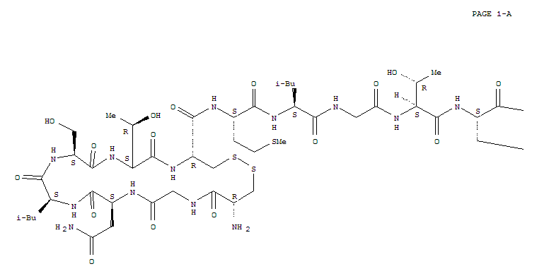 |  | What Nerds Laugh About...  Q: What do you do with a sick chemist?  A: If you can’t helium, and you can’t curium, you might as well barium  MCAT Question of the Week:  Which of the following is NOT characteristic of hydrogen bonding?  A. The hydrogen atom involved must be covalently bonded to a very electronegative atom.  B. The hydrogen bonds are typically weaker than ionic or covalent bonds.  C. The other atom involved in the hydrogen bond (not the hydrogen atom) must be covalently bonded to a hydrogen atom.  D. The other atom involved in the hydrogen bond (not the hydrogen atom) must possess at least one lone pair of electrons.  Answer: Turn over the page to find out!  A Quick Study Tip:  If you’re bored out of your mind trying to work your way through understanding how mitochondria and the golgi apparatus are related, try putting gummy bears in your book, eating them only when you’ve reached that section of the text. (MCAT QotW answer: C)  Could the University of Washington be your future Medical School?  The School of Medicine at the University of Washington is divided into six colleges, each of which sports multiple mentors and offers students the resources to earn an M.D. or Ph.D. For you ambitious kids, there is a program for obtaining both, called the Medical Scientist Training Program. UW has a total enrollment of 938 students.  In-state cost: $31,992 per year Out-of-state cost: $60,978 per year

