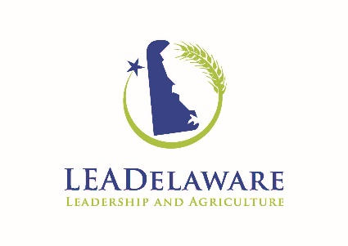

Applications due October 27, 2017 for the 2018-2020 Class

Dear Friend of LEADelaware,

LEADelaware is accepting applications for our next class of LEADelaware Fellows. This is a partnership of the Delaware Department of Agriculture and the University of Delaware in collaboration with numerous agricultural-related sponsors.

Applications are due October 27, 2017. Please see application materials as attached:

A. Program Information, including program schedule and dates;
B. Application Form;

You have been given this application: 1) at your request; 2) as another person has nominated you to be in the class; or 3) because you, (and/or your organization) are being asked to help surface suitable candidates.

All of the Application Materials are available from the LEADelaware website at http://sites.udel.edu/leadelaware/

Please contact us directly if you have any questions about the selection process or questions about any other aspect of the program. Thank you for your efforts in making Delaware’s agricultural, natural resources, and leadership development program a success!

Sincerely,

Kenneth Bounds Dr. Michelle Rodgers
Deputy Secretary Associate Dean and Director of Cooperative Extension Delaware Department of Agriculture University of Delaware
2320 South Dupont Hwy 113 Townsend Hall
Dover, DE 19901 Newark, DE 19716
302-698-4500 302-831-2504
Kenneth.Bounds@state.de.us mrodgers@udel.edu

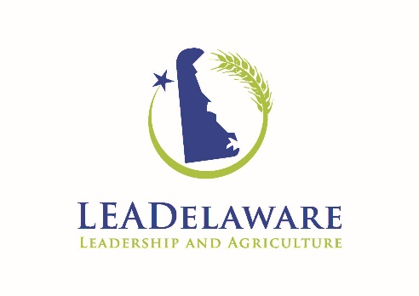

Program Information

LEADelaware is an agricultural and natural resource leadership program designed to help build the next generation of leaders within the food and fiber industries that influences our food system, our economy, and our environment. Leadership is a critical component for any industry to respond to the political, social and economic issues it faces on a day-to-day basis. Agriculture and related industries need experienced and trained advocates to provide a voice and a direction for the future. The business of agriculture has grown in new areas with new technology and production strategies. The need to translate the needs of this industry to the public and policy makers is critical.

LEADelaware finds itself in good company with over 35 state and international agricultural leadership programs. The philosophy of LEADelaware is to build leadership capacity in agriculture and natural resources in Delaware by investing in a class of emerging leaders. In our framework, leaders are not born nor can we simply make someone a leader by teaching them a set of skills. However, we can invest in emerging leaders by imparting knowledge, skills, and opportunities to lead.

The LEADelaware Program will seek to recruit a class of 10 - 15 fellows in Delaware and take them through a two-year program that will:
- Provide an atmosphere of individual and group learning and growth
- Build leadership skills and capacity of the participants
- Provide opportunities for participants to practice these skills within the program
- Facilitate this learning in the context of current issues and problems facing the state, agriculture, and natural resource issues

ELIGIBILITY & SELECTION REQUIREMENTS

Eligibility Requirements:
To be considered for a LEADelaware Fellowship, applicants must have the following qualifications:

- U.S. citizen; and a resident of Delaware or working in Delaware agriculture or natural resources for at least 2 years.
- LEADelaware operates without discrimination on the basis of race, color, national origin, sex, age, or handicap. Diversity of the fellows cohort is desired. The health and safety of all class members, particularly on any national and international trips, and in activities (such as use of a physical ropes/challenge course), is of primary importance.

- Applicants need the ability to be away from their work, families, and other activities for the time required by the LEADelaware program.
- Applicants must have the willingness to travel, including throughout Delaware, throughout the nation, or to international locations.
- Applicants must have leadership or emerging leadership experience in areas such as production agriculture, forestry, agribusiness, natural resources, rural or community subject areas.
- All applicants must submit a completed application form by October 27, 2017.
- Applicants must have the willingness and ability to pay the $2,000 tuition by the designated due dates.
- Applicants must have a willingness to complete a leadership project or class practicum and fully immerse himself/herself in the leadership process.

Selection Criteria:
In addition to the eligibility requirements, the following criteria will be considered in the selection of applicants to be in the LEADelaware Fellowship program. Applicants should have:
- Demonstrated interest in leadership knowledge, skills, and abilities;
- A commitment to the agricultural industries, and/or the natural resources-based industries, and/or the Delaware community;
- An interest in involvement in communities, Delaware, this country and our world;
- Evidence of emerging leadership;
- Personal goals for improving and applying leadership abilities;
- Contribute to valuing diversity of the class.

Selection Process:
The selection process is the responsibility of the Selection Committee of LEADelaware. The LEADelaware Selection Committee will review and screen all applications and make selection. Applicants will be notified on or about December 1, 2017.

The maximum and ideal class size will be 10 - 15 participants. Applicants who are not accepted due to class size or class balance, and who remain eligible, will be encouraged to reapply for the next class. We are looking for participants from all regions of Delaware with diversity in occupations, education, perspectives, and experience, as well as participants who will contribute to the class as well as gain something from the class.

Those involved with various aspects of production agriculture are especially encouraged to apply, as there is a goal to have half of the class be representative of production agriculture. LEADelaware’s definition of agriculture is as broad as possible, including, for example, production of forest products, aquaculture, fisheries, all aspects of the equine industry, greenhouse and nursery production, honey bees, wine grapes, fruits, vegetables, dairy, livestock, ag-tourism, grain, poultry, etc. Tuition scholarships may be available for producers from various industry organizations – contact us to learn more.

Tentative PROGRAM CALENDAR & EXPECTATIONS
Calendar:
Dates/Locations | General Overview | Leadership Skills
Candidates Notified  December 1, 2017 | All candidates will be notified by mail as to their status – accepted or denied
January 10, 2018 | First tuition payment due.
Session I  January 30 – February 1, 2018  Rehoboth Beach, DE  3 day, 2 night OVERNIGHT | Introduction to LEADelaware, policy and procedures; Overview of Delaware agriculture & programs | Personality Assessments; Berkman Assessments; Lerner College Facilitation Skills – Intros, Meeting Managing
Session II  March 7-8, 2018  Newark, DE  2-Day; OVERNIGHT | Ag Science and Ag Research and how it ties back to the farm. | Change Leadership
Session III  April 17-18, 2018  Georgetown, DE  2 day, 1 night  No Overnight | Production Animal Ag, economic impact; Nutrient Management;  Poultry Industry Cradle to Table | Conflict Management Skills  Conflict Style Assessment
Session IV  August 14-15, 2018  Sussex County  2 day; No Overnight  Carvel Research and Extension Center | Agronomics; Grain marketing highlights, economic impact, issues, including risk management, GMO’s, technology and climate change impacts; Vegetables Production | Leadership Styles
Session V  October 24-25, 2018  New Castle County  2 day; No overnight | Horticulture - ornamentals and nursery; Forestry; Natural Resources | Communications skills – presentations, working with traditional and social media
January 10, 2019 | Final tuition payment due
Session VI  Jan. 22-23, 2019  Dover, DE  2 day; No overnight | Public policy at the state level; meeting with legislators, state organizations/agencies and the roles of lobbyists | Networking
Session VII  March 18-20, 2019  Washington D.C.  3 day; 2 night  OVERNIGHT | Public policy at the National level, including meeting with legislative staff, national organizations/agencies, the roles of lobbyists | Advocating
Session VIII  August 13-14, 2019  Wilmington, DE  2 day; OVERNIGHT | Food System overview, local, urban and export/import; | Diversity
Session IX  October 4-5, 2019  Kent County area  2 day; No overnight | Non-traditional agriculture, including equine, agritourism, economic impact, issues and growing trends; | International Study; Team building
Session X  Date & Location TBD | International Study Trip  Feb/March 2020
Graduation  One month after International Study | Formal graduation with keynote speaker; include presentation from Fellows

General Expectations:

Full attendance and participation is expected.

There is an attempt to keep the seminars as enjoyable, light and fun as possible while we learn about some serious topics. We try to mix and vary the teaching techniques used (some lecture, tours and field visits, role playing, discussions, assessments, hands-on learning, etc.). Ultimately, it will be up to each individual person to determine how much he or she will get out of the experience and how the individual will apply what is learned. The program provides many opportunities, but it will be up to the individual on how best to utilize the training, the new contacts and networking opportunities, resources, information, and leadership examples.

Besides the general topic or theme of each seminar, leadership skills and discussions will be included within most seminars. We will also attempt to learn more about the economics, history, citizens, leaders, agriculture, natural resources, and current issues of the community or region hosting the seminar.

Plan on committing a minimum of 20 days to attend seminars. Please arrive at the seminars thinking of it as attending class in a retreat setting. Though breaks are taken throughout the day, not every seminar will offer a lot of time to make phone calls or complete other projects. Also keep in mind that phone access may be limited in times of tours or when staying at some facilities.

Plan on using 8-14 days for a study tour, depending on the travel destination(s), the time of year for travel, the needs of the class, the overall budget, etc.

There will be assigned reading and studying outside of the seminars, but these will be reasonable in length. You are expected to put some time into the program between seminars. Fellows will be expected to come prepared for the sessions and at times present, organize, introduce, and contribute to the sessions.

Fellows occasionally are invited to attend events important within the agriculture, natural resources, and rural communities, which are not mandatory for the completion of the LEADelaware Fellowship, but are optional opportunities Fellows may want to enjoy.

Dress for the seminars is commonly business casual (pants other than jeans, collared shirts—button-down or golf/polo shirts, or sweaters, optional jackets and ties and the equivalents for ladies), but there are times where business dress (suits) are more appropriate. During some outdoor activities or tours, casual attire (jeans or shorts, T-shirts or other casual clothes, athletic shoes, hiking boots, etc.) works best. Information about what to expect during the seminar will be sent out ahead of time to help you in packing and planning.

Email will be the basic means of communication before, during and after seminars. Details of each seminar will be e-mailed to Fellows usually a few weeks prior to the actual seminar.

2018 – 2020 Application Form Class V

Note: Please read the entire application form before beginning to complete it. The application can be submitted in paper form (hand-written), but we would prefer it as a Word or Adobe PDF file sent via e-mail. Please send the completed application to:
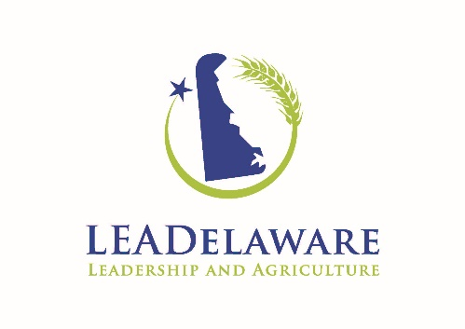
Grace Wisser
University of Delaware
College of Agriculture and Natural Resources
531 S. College Avenue
113 Townsend Hall
Newark, DE 19716
302-831-4722
gwisser@udel.edu

The application form is available as a WORD or PDF document and may be retrieved from the LEADelaware website at: http://sites.udel.edu/leadelaware/

You may use the document application form and adjust the spacing and layout as needed to complete the form, as long as the integrity of the form is kept and all requested information is submitted.

Incomplete applications may not be processed. We advise you to keep one copy of your application for your records and return one complete copy to LEADelaware. Please do not attach extra materials; only those materials requested will be reviewed. Remember, all applications must be received by October 27, 2017.

- Personal Information (not used in the selection process).

Full Name (as on legal documents such as your birth certificate or passport):
Name you commonly go by (This is the name that will be printed on name badges)
Gender:
Date of Birth:
U.S. Citizen since:
Delaware Resident since:
Current county of residence:
Home Address:

Business or Farm Name:
Job Title:
Business or Farm Address:
Mail correspondence to: choose either HOME or BUSINESS
Home Phone Number:
Business Phone Number:
Cell Phone Number:
Preferred Email Address:
Emergency Contact & Phone Number
List Food Allergies:
Are you a (full time, part time, or hobby) farmer/grower/producer/farm operator/land owner, etc.
Do you actively engage in social media? If so, what platforms?

2. Education and Training Schools, Short Courses, Military Training, Leadership-Related training, FFA, Grange, etc. (List most recent first. Indicate if you attended, graduated, earned degree(s), etc.)

Dates | School/Course | Location | Attended/graduated/degree earned
Describe any other education or training, including leadership topics, that you feel is relevant:

3. Work Experience.

Off-Farm Employment Experience (paid or not paid, if applicable). Include: type of work, company, business or agency name, if self-employed, full-time/part-time, etc. Please list most current work experience first.
Dates | Company | Position | Key Responsibilities
On-Farm Experience (if applicable). Please describe your experience in an agricultural or natural resources field of any kind, whether it is your major occupation, a side project, hobby, or family activity. Describe the size and scope of the enterprise and your involvement or responsibilities relating to it.
Significant Work Accomplishment(s). Cite from any of the above work experience a project or program that you initiated, developed, organized, led, or in which you played a major part. You may list work-related goals you have reached or accomplishments and their result or impact.

4. Organizational Participation. Please indicate participation in professional, community, civic, religious, governmental, farm, commodity, educational, industrial, social, rural, land use, environmental, or other organizations. Indicate if you were a member, held office, or what activities or leadership roles you participated in within the organization:
Dates | Organization | Member, Officer, Leadership Role, Activity
Significant Organization Accomplishment(s). Cite from above organizational participation a program or project that you initiated, developed, organized, led, or in which you played a major part. You may list goals reached, accomplishments, and results.

5. Travel experience. Briefly describe your level of travel experience, whether through business, pleasure, family visits, Peace Corps, church missions, civic groups, or any other reasons. Include travel within the state, region, the United States, and to other countries.

6. Awards and Honors. List any recognition you have received for your efforts in professional, organizational, and personal activities.
Date | Award/Honor/Accomplishment | Granter and how recognized

7. Summary. Please answer the following question so that the Selection Committee can better understand you.
Summarize your thoughts on why you want to participate in the LEADelaware, and what your leadership goals include at this point. How do you intend to use the leadership abilities you gain as a participant in LEADelaware? Answer in 500 words or less. If you are submitting a handwritten application, give a brief one sentence summary/title and then use an additional page and attach to the application form.

8. Reference - Please list one non-family member we could call to learn more about you.
Name:

Position:

Telephone:

E-mail:

Your relationship to this person:
(how this person knows you)

Please return ONE copy of the completed materials by October 27, 2017. Applications must be received by October 27, 2017. Please retain a copy of the completed application materials for your own records.

You can send an electric copy of your answers via e-mail. We suggest you save the file as: LEADappyourname.doc
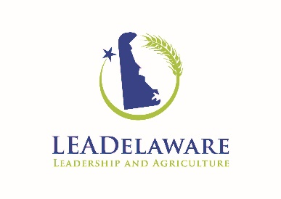
Mail to: Grace Wisser
University of Delaware
College of Agriculture and Natural Resources
531 S. College Avenue
113 Townsend Hall
Newark, DE 19716
302-831-4722
gwisser@udel.edu

Thank you for completing and forwarding your application!

