- Delaware State Fair
  - “Results Emails” will be sent next week to each exhibitor. Note: Each entry will receive one email with ribbon color any noted comments
  - Optimistically hoping DSF will be on schedule as normal next year (July 22-July 31, 2021)
  - A few Face to Face Educational Events that were not held at the fair, have been approved and the fair will offer premiums as they typically do. Sign up information will be available soon. These events include:
    - Judging Contests: Clothing, Wildlife and Horticulture Sept 14 (3pm-6pm) and 15 (3pm-6pm). Info will be out shortly, watch for blog post.
    - State Archery Contest: September 19, DSF Grounds
    - Lawn Tractor: September 23 (rain date 9/24) Taylor and Messick
    - Clothing Showcase – information for virtual event will be forthcoming from the state 4-H office.

- We hope you are finding the Kent County 4-H Blog helpful. We will be enabling the post comments section for anyone with questions or comments. Feel free to post questions, or answer questions if you are able.

- Virtual Basket Auction will be Sept 11, the online silent auction will start at 12noon and will begin closing at 8:00pm – We are seeking donations! Contact Kristin or Caroline All items live/silent due to the 4-H office by August 24th or close to that date. Curbside drop-off available, please contact Caroline to set up time.

- National Youth Science Day is now the 4-H STEM Challenge: MARS Base Camp
Free Kits – Family Size (4 youth) or Leader Pack available https://bit.ly/DE-STEM-kits
Limited Supply, request your kits as soon as possible; no later than Aug 24

- Club News – Due 25th of each month; will be combined into one post (August 25)
- 4th H for Health Club Challenge- Participation Forms Due August 31, email to KKlair@udel.edu
- Record Books - Due September 18th
  - A general record book highlights the general 4-H activities, community service/ citizenship initiatives and leadership experiences that 4-Hers participate in during the 4-H year
  - A project record book highlights 4-H work (meetings, field trips, projects, presentations etc.) that 4-H youth partake in related to a specific project area, such as Horticulture or Foods.
  - Check with your 4-H club leader about submission options for your club. Some clubs require submission to the leader prior to submitting to the county office.
  - Electronic Submission is an option, in-person drop off on Wednesday, Sept 16 from 10am-12pm or Friday, Sept 18 from 10am-12pm, or contact the office to arrange another time.
  - If you plan on participating in the September face to face events listed at the top of this document, you may list that you plan to participate. Record books are due prior to these events taking place.
- Record Book Help – August 25 (5pm) or Sept 1 (9am) or Sept 8 (1pm) by Zoom (see information on Blog) https://www.youtube.com/watch?v=43VcS5l_cN0)

- Achievement Banquet October 18 – Virtual Celebration
Award Forms – Due September 18
If you have forms to submit, they can be turned in during the drop off date/times at the 4-H Office: Wednesday, Sept 16 from 10am-12pm or Friday, Sept 18 from 10am-12pm
Submissions after Sept 18, will need to be submitted electronically.

Many forms are found here:
https://www.udel.edu/academics/colleges/canr/cooperative-extension/personal-economic-development/4H-youth-development/by-county/kent-county/

Junior Leaders – 1st year only
Charter Seal –
2020: #2 and #3 Leader and Jr Council Meetings 3 required (not 5)
#9 List 2 for Club, 2 for county, 1 required for state/national
Community Service Award
2019-2020 Youth ages 11 and under (including Cloverbuds): 15 Hour Requirement
2019-2020 Youth 12 and up: 30 Hour Requirement
Links Applications
Everline Leadership Award
Pritchett Award
Public Presentation Award
Diamond Clover Reports

- Delaware 4-H Shooting Sports Instructor – Virtual Fall Meeting September 23
- 4-H Enrollment Process – Members: enrollment opens October 1; March 1 Deadline for a re-enrollments

- National 4-H Week October 4-10, 2020)
  - Litter Barrel and Window Display – To be determined if events will be postponed
  - Tuesday, October 6 – Wear 4-H Green Day!

- Paper Clover Promotion: October 7-18, 2020
Please consider purchasing a paper clover at any Tractor Supply Store to support the local 4-H programs. The funds do arrive in our county program and we appreciate those who have purchased paper clovers in the past.

- Achievement Banquet – October 18 at 3pm; Planning a virtual format (can be easily transitioned to in person if approval is granted) Will be using “Zoom Webinar”. We will be asking for photos to show when youth are “presented” with awards and recognition. Connection information will be available at a later date.

Other Announcements:
Preparing for lifting of restrictions… PPE Supply

4-H Exchange Group Looking for a New Advisor and Members

America’s Farmers can help the 4-H Program!

Delaware 4-H Hall of Fame Request

Operation Christmas Child

DSF Junior Board Applications Now being Accepted

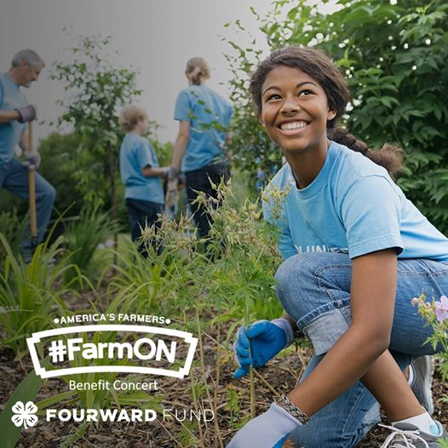
The Farm Journal #FarmON Benefit concert supporting the #FOURWARD fund is on August 27 @ 7 p.m. CDT / 8 p.m. ET at https://bit.ly/3iOQbBT!

Join Meristem Crop Performance, Culver's, Bayer, Pivot Bio, and Corteva Agriscience in supporting #4H’s commitment to provide emotional support, a sense of belonging, meaningful learning, and #Opportunity4All kids.

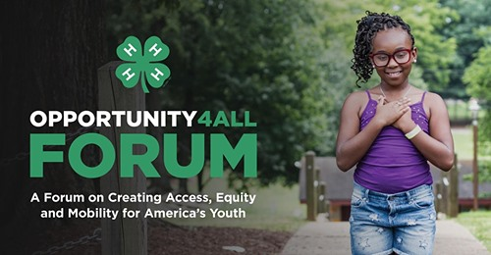
Join National 4-H Council, youth leaders, Cooperative Extension, and experts for a discussion on creating access, equity and mobility for America’s youth. Watch and learn more: https://4-h.org/Opportunity4All/

Journey to the Red Planet in this year’s #4HSTEMChallenge, Mars Base Camp. The four included activities allow kids to explore Mars in exciting ways like targeting the perfect landing zone, building a rover and growing food to sustain their mission team. Get started right away with the FREE activity, Insight from Mars, that teaches kids to code using CS First and Scratch. Learn more and find the free activity at at https://bit.ly/312Lgas #4HatHome

It’s Crop Risk Services
virtual fair time! Crop Risk Services believes all kids should have an opportunity to show off their hard work. That’s why they’ve invested $25,000 in the #FOURWARD Fund! Learn more about the virtual fair for 4-H’ers and register your project by 8/20 at https://bit.ly/3iLgubZ.

