Higher Education Consortia
News and Updates: 2017 Delaware Cost Study
August 2017
Coming Soon - You will have the ability to compare Direct Expenditures per SCH across your Institution by just clicking on a button.

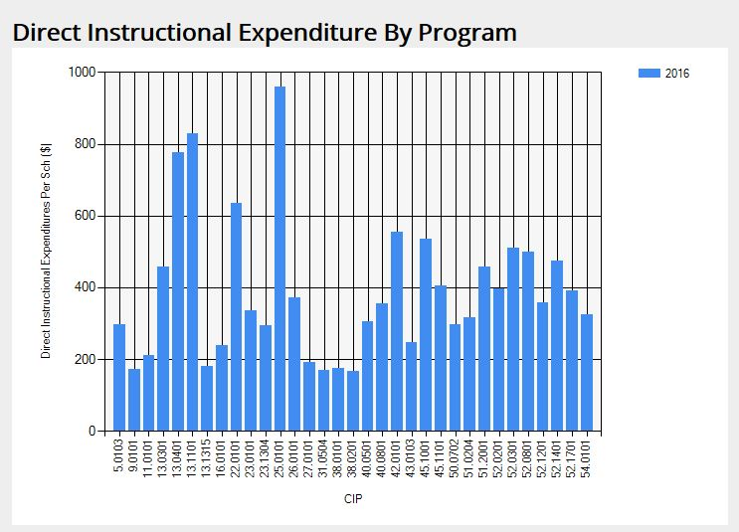
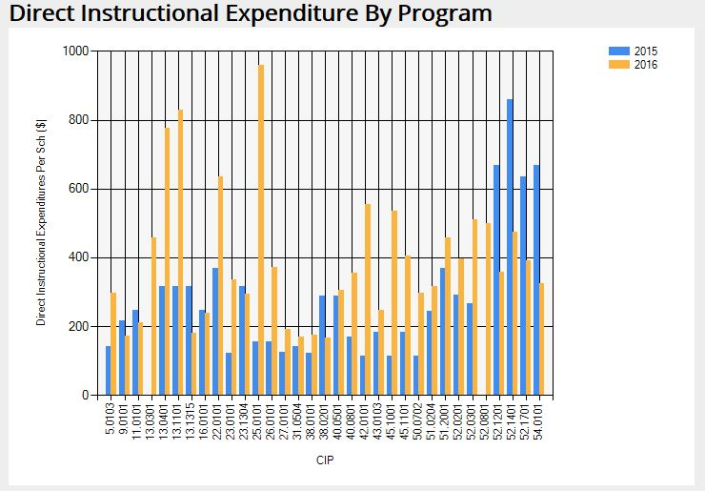

This tool will allow you to compare, by CIP, the Direct Expenditures per SCH. You can choose one year, or add a year for comparison, by program. This feature, along with some updates to your home page, will be available in the near future. Look for an email announcing when this new visual information will be on the web portal. We hope you will find this feature valuable.
FYI – Institutional Reports and the National Norms are now available in a .txt file if needed. Please contact our office at ire-cost@udel.edu for additional information.
Advanced Analysis of the Delaware Cost Study Results
The Cost Study team is exploring innovative uses of our data beyond simply comparing individual program’s cost per student credit hour with national norms. Our current goal has two-fold: first, peer group selection is critical for benchmarking as it determines whom you compare yourself with. One of our research projects developed a refined peer selection approach to allow participants to identify their discipline-level peers for more accurate, data-informed program evaluation.
Second, institutional leadership and department chairs need measurable goals when benchmarking instructional productivities and expenditures. Using a data envelopment analysis (DEA) approach, we benchmark individual programs with their most efficient peers at the disciplinary level in terms of their allocation of faculty resources and instructional costs. For each program, DEA yields an efficiency number indicating its distance from its most efficient peers and a data-driven optimal solution.
The preliminary results of the above research were presented at Association of Institutional Research Annual Conference 2017, Washington, DC (http://forum.airweb.org/2016/pages/forum-sessions). More updated work will be shared in workshops and speaker sessions at regional IR annul conferences this fall, including SAIR 2017 (http://www.louisianau.com/sair17/ ), CIRPA 2017 (https://cirpa-acpri.ca/) , CAIR 2017 (http://www.cair.org/conferences/annual-conference/) and NEAIR 2017 (https://www.neair.org/2017_conference_program.php).
Please contact Ti Yan at yant@udel.edu or Tom Eleuterio at tommyu@udel.edu for more information.

