USING PROMPTS

Adding prompts to a report adds versatility and interactivity for people who will use your report. A prompt is in essence a question asked of the user that will narrow the results in the report. There are various types and ways to use prompts:

- Add a Pre-written Prompt (found Insertable Objects in Prompts folder)
- Add a simple prompt with a Filter Expression
- Add a Text Box Prompt
- Add a Value Prompt
- Create a Prompt Page with a Cascading Prompt

A. Add a Pre-written Prompt for Purpose

- Open Report Studio using UD Financial Data Mart

- Click Create a new report or template
- Double-click List

- Add the following fields to the work area:

Field Name | Query Subject | Folder
PURPOSE | Chart of Accounts | Purpose
ACCOUNT | Chart of Accounts | Account
ACCOUNTING_DT | Trans Detail
JOURNAL_ID | Trans Detail
TRANS_DESCRIPTION | Trans Detail
TRANS_AMOUNT | Trans Detail

- Save this report and name it Prewritten Prompt

- Add the following pre-written Filters (from the Filters folder):
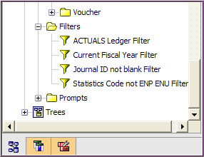

-ACTUALS Ledger Filter
-Current Fiscal Year Filter
-Journal ID not blank Filter
-Statistics Code not ENP ENU Filter

- Add the following pre-written Prompt (from the Prompts folder):
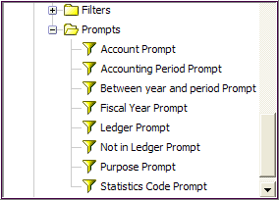

• Purpose Prompt

- Save your work
- Run the report

B. Add a simple Prompt with a Filter expression

- Click on the ACCOUNTING_DT heading and click Sort and then Ascending

- Add a simple prompt to return dates greater (older) than a date entered
  - On the toolbar, click Filters and Add
  - From the Data Items tab, double-click ACCOUNTING_DT
  - Type >?Acctg Date?, your expression should look like this:

[ACCOUNTING_DT] >?Acctg Date?

  - Validate and click OK twice
    - A prompt page will appear with a calendar and a clock
    - Choose a date from the prior month, accept the default time
    - Enter a Purpose and click OK
- Save your work

- Run the report

C. Add a Text Box Prompt to a report page

- Click Open
  - Go to Public Folders, Ellen Training, Report fpr class
  - Double-click on class TEXT BOX PROMPT

- Immediately save in My Folders and name it Text Box Prompt

- On the toolbar, click Filters and Add
  - From the Data Items tab, double-click PURPOSE
  - Create the expression :

[PURPOSE]='XXXX000000' (enter your own Purpose instead of XXXX000000)

  - Validate and click OK

- Click the Toolbox tab

- Drag a Table to just below the title, you will see a thick, blinking line on the right

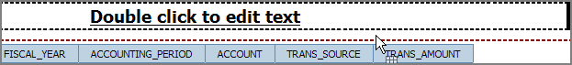

  - Make it 2 columns and 2 rows and click OK

  - Your work area should look like this:

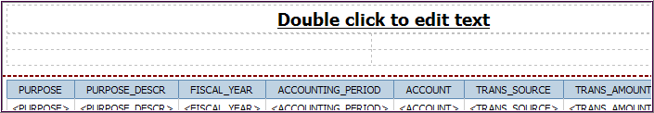

- Still in the Toolbox, drag a Text Box Prompt into the upper right table cell

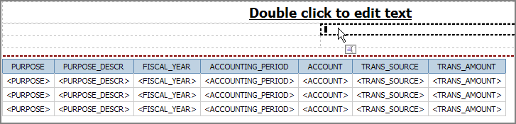

  - This will open the Prompt Wizard
  - Choose Parameter window:
    - Change Parameter 1 to Fiscal Year
    - Click Next

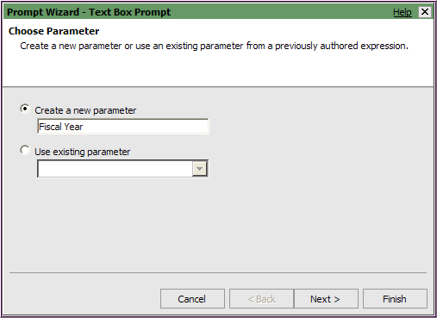

  - Create Filter window:
    - Click the ellipses
    - Package item - open UD Financial Data Mart package/Trans Detail/Dates folder, select FISCAL_YEAR and click OK
    - Click the Finish button

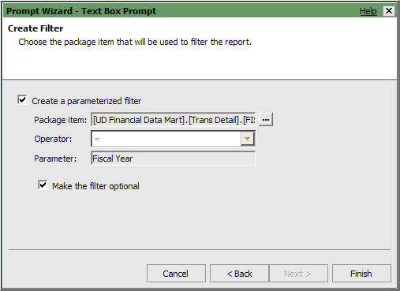
- Drag another Text Box Prompt into the lower right table cell

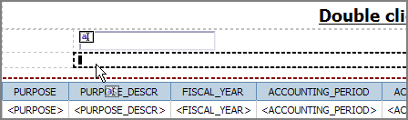

  - This will open the Prompt Wizard
  - Choose Parameter window:
    - Change Parameter 1 to Period
    - Click Next button

  - Create Filter window:
    - Click the ellipses
    - Package item - open UD Financial Data Mart package/Trans Detail/Dates folder, select ACCOUNTING_PERIOD and click OK
    - Make this prompt optional - check the box Make the filter optional
    - Click the Finish button

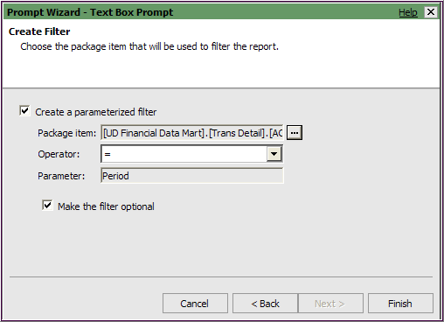

- Your work area should look like this:

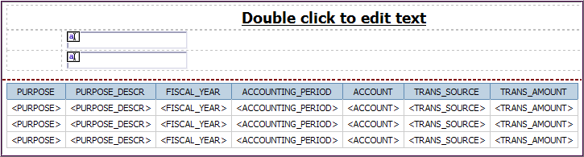

- Still in Toolbox, drag a Text Item to the into the upper left table cell
  - Type – Enter Fiscal Year:
- Drag a Text Item to the into the lower left table cell
  - Type – Enter Period:

- Highlight both left table cells and click the Right justify button

- Your work area should look like this:

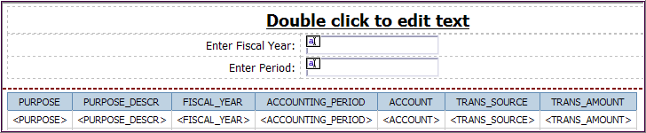

- Save your work

- Run the report and enter a Fiscal Year in the prompt page

- When you’ve run the report once, you will be able to change the filters for Fiscal Year and Period from Cognos Viewer to get new results.
  - Change the values in the Text Box Prompts
  - Click Run

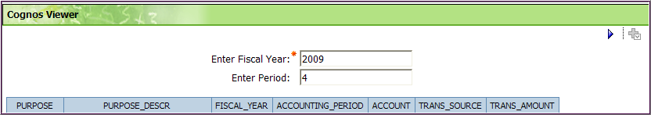

D. Add a Value Prompt to a report page

- Click Open
  - Go to Public Folders, Ellen Training
  - Double-click on class VALUE PROMPT

- Immediately save in My Folders and name it Value Prompt

- On the toolbar, click Filters
  - Add the following filter using the Data Items tab:

[PURPOSE]='XXXX000000' (enter your own Purpose instead of XXXX000000)

  - Validate each one and click OK (twice)

- Click the Toolbox tab and drag a Value Prompt to the left of list in the work area (look for thick, blinking line)

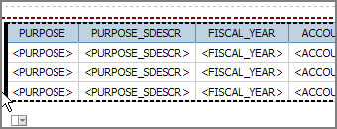

- This will open the Prompt Wizard
- Choose Parameter window:
    - Change Parameter 1 to Period
    - Click Next
- Create Filter window:
    - Package Item - click the ellipses
    - Package item - open UD Financial Data Mart package/Trans Detail/Dates folder, select ACCOUNTING_PERIOD and click OK
    - Make this prompt optional - check the box Make the filter optional
    - Click Next

- Populate control window:
      - Notice that Create new query is checked and Name is Query2 – leave both as is
      - Click Finish

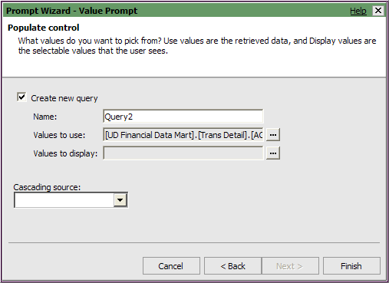

    - Your work area should look like this:

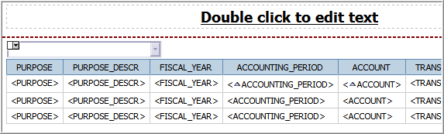

5. In the work area, highlight the Value Prompt by clicking on it
- Go to Properties pane
- Under General/Auto-Submit – change to Yes
  - Click ACCOUNTING_PERIOD column heading
    - Click Sort
    - Choose Sort Ascending

6. Save your work

7. Run the report

- When you’ve run the report once, you will be able to change the value for the Accounting Period from Cognos Viewer to get new results.

- Change the value with the drop-down list in the Value Prompt
- The report will re-run automatically
- No need to click Run

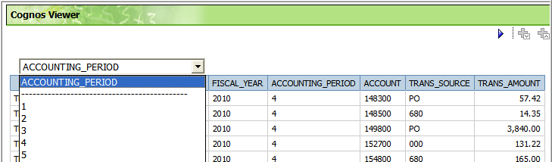
________________________________________________

E. Create a Prompt Page with a Cascading Prompt

With Cascading Prompts, you create a series of prompts that are hierarchical. When a prompt value is chosen, it determines the values available for the following prompt.

- Click Open
  - Go to Public Folders, Ellen Training, Reports for Class
  - Double-click on class CASCADING PROMPT

- Immediately save in My Folders and name it Cascading Prompt

- On the toolbar, click Filters
  - Add one filter using the Data Items tab

[PURPOSE]='XXXX000000' (enter your own Purpose instead of XXXX000000)

  - Validate and click OK

- Open Page Explorer, click Prompt Pages

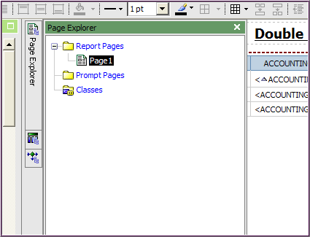

- It will look like this:

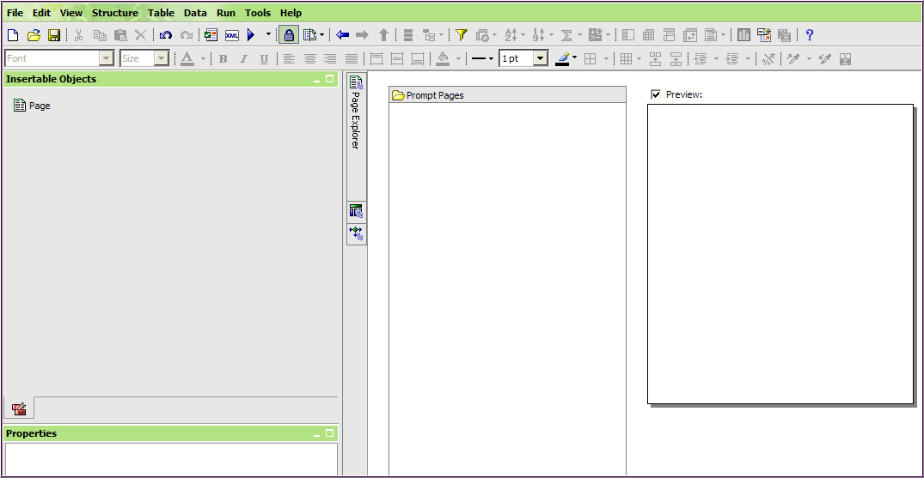

- From Insertable Objects, drag Page to the Prompt Page pane

- Double-click Prompt Page1 to open it (it will create a blank work area)

- From the Toolbox tab, drag a Table into the work area (you’ll see a very long blinking , black line)

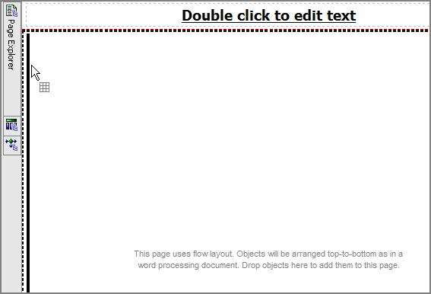

  - Enter - Columns 3 and Rows 3 and click OK
  - Upper left table cell – drag a Text Item, type: Fiscal Year
  - Middle left table cell – drag a Text Item, type: Accounting Period
  - Bottom left table cell – drag a Text Item, type: Trans Source
  - Your work area should look like this:

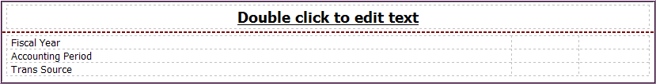

- Scroll to the bottom of the Toolbox:
- Drag a Text Box Prompt to the upper center cell; this will open the Prompt Wizard

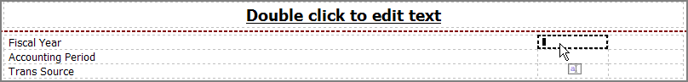

- Choose Parameter window:
    - Change Parameter 1 to Fiscal Year
    - Click Next
- Create Filter window:
    - Package Item - click the ellipses
    - Package item - open UD Financial Data Mart package/Trans Detail/Dates folder, select FISCAL_YEAR and click OK
    - Click Finish

  - Drag a Value Prompt to the middle center cell; this will open the Prompt Wizard

- Choose Parameter window:
    - Change Parameter 1 to Accounting Period
    - Click Next

- Create Filter window:
    - Package Item - click the ellipses
    - Package item - open UD Financial Data Mart package/Trans Detail/Dates folder, select ACCOUNTING_PERIOD and click OK
    - Operator – change to in
    - Click Next

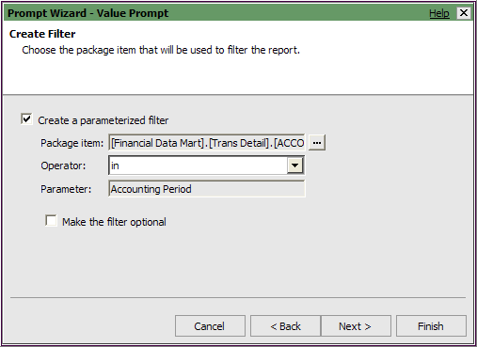

- Populate control window:
    - Note – the prompt will create a new query – Query2
    - Cascading Source – change to Fiscal Year
    - Click the Finish button

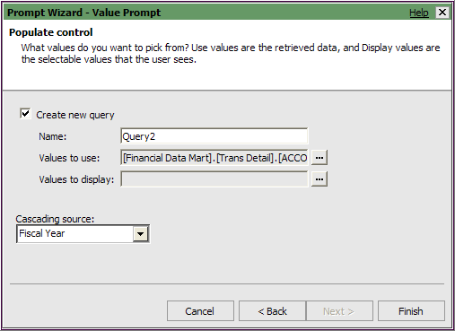

  - Drag a Value Prompt to the bottom center cell; this will open the Prompt Wizard

- Choose Parameter window:
    - Change Parameter 1 to Trans Source
    - Click Next

- Create Filter window:
    - Package Item - click the ellipses
    - Package item - open UD Financial Data Mart package/Trans Detail, select TRANS_SOURCE and click OK
    - Click the box for Make the filter optional
    - Click Next

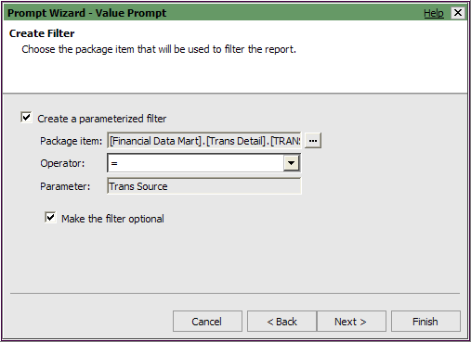

- Apply Filter window:
    - Leave Query1 checked and click Next

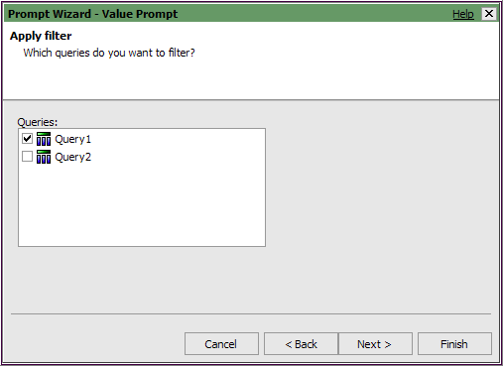

- Populate control window:
    - Note – the prompt will create a new query – Query3
    - Cascading Source – select Accounting Period
    - Click the Finish button

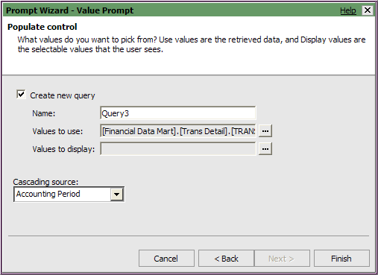

    - Your work area should look like this:

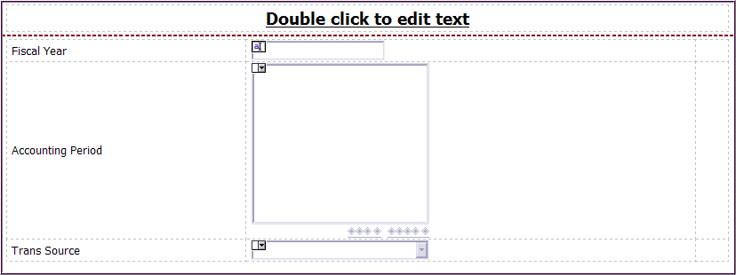
- From the Toolbox, drag a Prompt Button to the upper right cell
  - It says Next >
  - Click on the button and go to Properties
  - Under General category:
    - Type – change to Reprompt

- Drag a Prompt Button to the middle right cell
  - It says Next >
  - Click on the button and go to Properties
  - Under General category:
  - Type – change to Reprompt

- Drag a Prompt Button to the bottom right cell
  - It says Next >
  - Click on the button and go to Properties
  - Under General category:
  - Type – change to Finish

  - Your work area should look like this:

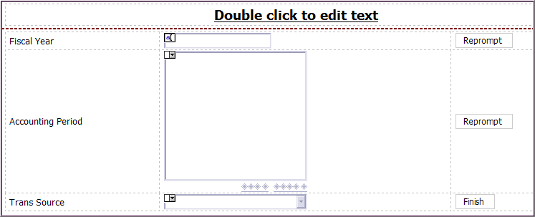

- Click inside the TRANS_SOURCE prompt box
  - Go to the Properties pane
  - Under Data/Sorting, click ellipses
  - Double-click TRANS_SOURCE to add it to the Sort List
  - It will sort this prompt list ascending – click OK

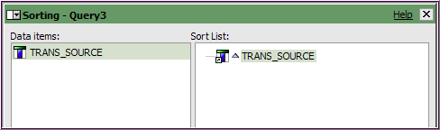

- Click inside the ACCOUNTING_PERIOD prompt box
- Go to the Properties pane
- Under Data/Sorting, click ellipses
- Double-click ACCOUNTING_PERIOD to add it to the Sort List
- It will sort the prompt list ascending – click OK

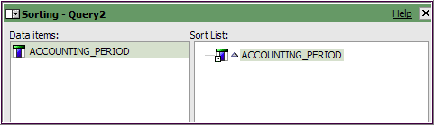

- Save your report and Run it

- The Prompt Page will appear:
  - Fiscal Year prompt – type in an FY such as 2010 and click Reprompt button
  - Accounting Period prompt – select a period (or periods) and click Reprompt button
  - Trans Source – this is an optional prompt; don’t select one the first time
  - Click Finish button (either one)

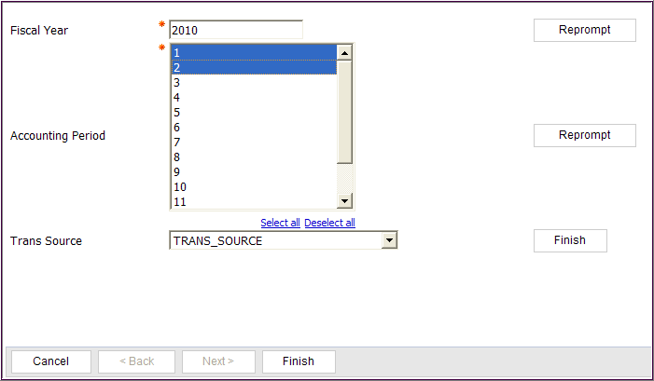

- View your results in Cognos Viewer
  - Note a few Trans Source values
  - Rerun the report from Cognos Viewer
  - Fill all three prompts this time including Trans Source

