Expressions
Cognos Training - Report Writing

- Expressions - general information

- Values will always be in ALL CAPS and have single quotes (e.g. ‘ABC’)
- Numbers do not need single quotes (e.g. 2010)

Equal (=) [DATA_ITEM] = ‘VALUE’

- If you don’t know the value for a data item, in the Expression pane, use the Select Value button
- Double-click a value to add it to the expression definition
- The value will be formatted correctly for the expression with single quotes

Like – use with % (wildcard) to select partial value found anywhere within a field

– use with _ to designate exact location of partial value within a field

[DATA_ITEM] like ‘% (partial)VALUE%’
Example: [PURPOSE] like ‘%17%’

This expression includes Purpose codes such as CHEM322217 and CHEM17S000.

[DATA_ITEM] like ‘____(partial)VALUE____’
Example: [PURPOSE] like ‘____17____’ (this is 4 _’s before and after the 17)

This expression includes Purpose codes such as CHEM175132 and CHEM17S000.

In list (in) [DATA_ITEM] in (‘VALUE’ , ‘VALUE’)

Not in list (not in) [DATA_ITEM] not in (‘VALUE’ , ‘VALUE’)

- If you don’t know the values for a data item, use the Select Multiple Values button
- Double-click a value to add it to the expression definition
- The values will be formatted correctly for the expression with single quotes and parentheses

Not Equal (<>) [DATA_ITEM] <> (‘VALUE’ , ‘VALUE’)

[DATA_ITEM] <> 0

[DATA_ITEM] <> ‘ ‘
(not equal to blank; there is a space between singe quotes)

- Always Validate your Expression Definitions and look for “No errors.” This will save you frustration later if your report has problems; you will know the issue is NOT your filters.

- Disable a Filter rather than deleting it.
- This gives you the option of re-using it at a later date

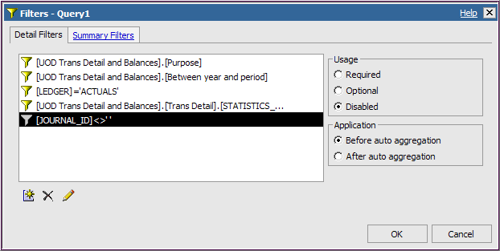

- Re-use expressions from existing reports or other places
- You must use Copy [Ctrl-C] and Paste [Ctrl-V]
- You could keep a Word document with your frequently-used expressions to save time and avoid keying errors.
- Note that every Cognos package will need to have its own set of expressions.
  - For example the ones for the UOD Trans Detail and Balances package must be separate from the Contract and Grants Data Mart

- Expressions – Dates
- Use the format yyyy-mm-dd

- Add Text to an expression with this syntax
(text stands for whatever verbiage you want to include):

[space] + [space] ’text’ [space] + [space]

- Help within Cognos for building expressions
- Click the Filter button
- In Available Components, click the Functions tab

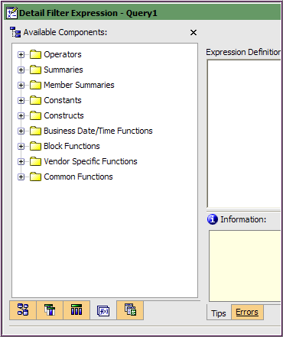
Functions tab

- Open one of the yellow content folder to see the list of functions
- Click on one of the functions
- The Information panel will display the syntax and other useful information about using that function
- For example this is the information for the Summaries function percentage:

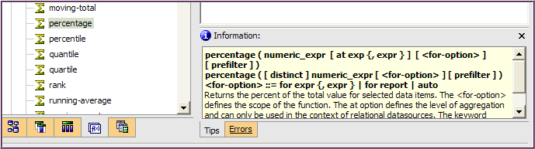

- IF THEN ELSE vs. CASE WHEN expressions

A good rule of thumb for deciding which of these similar functions to use:
Use If Then Else with simple expressions and Case When with more complex ones. The use of parenthes with If Then Else can get very confusing with complex expressions.

IF-THEN-ELSE expression
This is a conditional expression that uses the logic: IF a condition is true, THEN a statement is executed, or ELSE if the condition is false a different statement is executed.

Syntax:
IF (<condition>) THEN (<statement>) ELSE (<statement>)

Syntax for complex situation:
IF (<condition1>) THEN (<statement>)
ELSE IF (<condition2>) THEN (<statement>)
ELSE IF (<condition3>) THEN (<statement>)
ELSE (<statement>)

Example:
IF ([UOD Trans Detail and Balances].[Trans Detail].[FISCAL_YEAR]= 2008) THEN ([UOD Trans Detail and Balances].[Trans Detail].[TRANS_AMOUNT]) ELSE ( 0 )

CASE-WHEN expression
This is a conditional expression that uses the logic: CASE WHEN a condition is true, THEN a statement is executed, or else if the condition is false a different (statement) is executed. Additional conditions are introduced with the word WHEN. The expression always ends with the word END.

Syntax:
CASE WHEN (<condition>) THEN (<statement>) ELSE (<statement>) END

Syntax for complex situation:
CASE WHEN (<condition1>) THEN (<statement>)
WHEN (<condition2>) THEN (<statement>)
WHEN (<condition3>) THEN (<statement>)
ELSE (<statement>)
END

Complex example for elapsed percentage of a fiscal period:
CASE WHEN ([ACCOUNTING_PERIOD] = 1)
THEN (1/12*100)
WHEN ([ACCOUNTING_PERIOD] = 2)
THEN (2/12*100)
WHEN ([ACCOUNTING_PERIOD] = 3)
THEN (3/12*100)
WHEN ([ACCOUNTING_PERIOD] = 4)
THEN (4/12*100)
WHEN ([ACCOUNTING_PERIOD] = 5)
THEN (5/12*100)
WHEN ([ACCOUNTING_PERIOD] = 6)
THEN (6/12*100)
WHEN ([ACCOUNTING_PERIOD] = 7)
THEN (7/12*100)
WHEN ([ACCOUNTING_PERIOD] = 8)
THEN (8/12*100)
WHEN ([ACCOUNTING_PERIOD] = 9)
THEN (9/12*100)
WHEN ([ACCOUNTING_PERIOD] = 10)
THEN (10/12*100)
WHEN ([ACCOUNTING_PERIOD] = 11)
THEN (11/12*100)
ELSE
(100)
END

- Use the Function tab in the Expression window to help you write your expressions.
- Click the Functions tab
- Open the Constructs folder
- Double-click if then else to add it to the Expression Definition
- A template will appear; you will replace the phrases <condition> and <expression> with your own fields and expressions
- The Information box gives an example to follow.

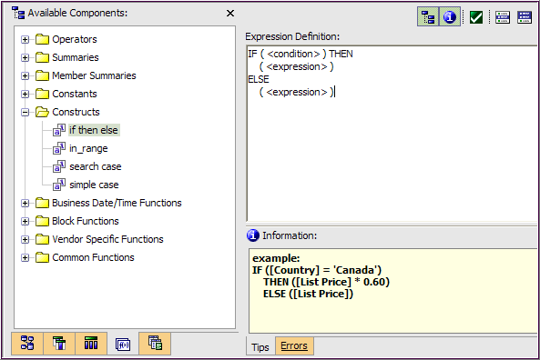
- Any field with this icon (builder's square) is a number and is auto-aggregated in Cognos.

You may need to click the After auto-aggregation radio button.

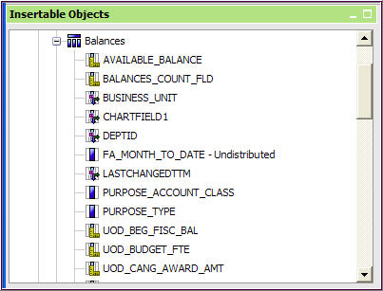

  - When using the field in a Filter , change the Application setting to "after auto aggregation" to get valid results

