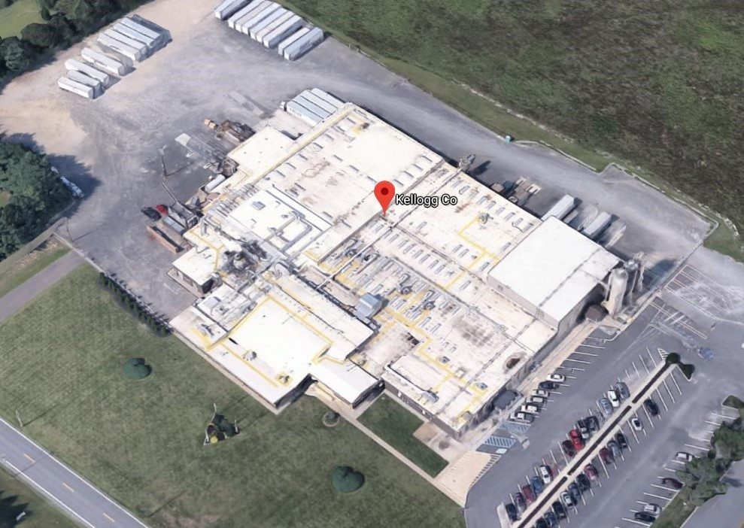

Kellogg Co.
  - Energy audit

UD EPA P2 Center

February 4, 2020
On December 20, 2018, the University of Delaware Industrial Assessment Center, under a grant from the EPA Pollution Prevention program, performed an energy, water, and waste reduction audit for Kellogg Blue Anchor in Hammonton, NJ. Three students contributed, providing hands-on training to their overall engineering education.

The 60,000 ft2 plant manufactures frozen waffles using a process that includes pneumatic conveying of flour to mixers with other ingredients to make batter, then pumping batter to waffle iron rotating stations to form waffles, picking waffles off irons with compressed air or vacuum, mechanically conveying waffles through a freezer to 10 F, then packaging.

Plant electric consumption is 16,052,662 kWh/year (incl. from fuel cell plant), 20 % by the waffle irons.
Plant gas consumption is 11,871 MMBTU/year (not incl. by fuel cell plant), 58 % for space heat by heaters.
Plant existing Best Practices include VFD ammonia compressors, proper temperature setpoints, utilization of air compressor cooling exhaust for supplemental space heating, daylighting through many skylights, interlocking the compressed air and vacuum picker ports with waffle iron wheel operation, and occupancy sensors for freezer lighting.
10 recommendations were made that would reduce electric consumption by 5.5 %, gas consumption by 62 %, and carbon dioxide reduction by 11 %. 5 recommendations are in-progress at the date of this report, 3 being planned, and 2 still under consideration.
Prof. Keith Goossen, 107 Evans Hall, Newark DE 19716, goossen@udel.edu, email for a free audit at your plant today!

Kellogg Co.  - Recommendations |  | The recommendations are color coded: green means implemented or in-progress, blue means planned, black means still under consideration, red rejection.
1  Adjust waffle iron room ventilation saving fan energy by 45,030 kWh and gas heat by 1,250 MMBTU/year  2  Turn off warehouse wall fans in winter saving 1,820 kWh/year and 750 MMBTU/year gas heat  3  Heat water with refrigeration reject, saving 3,186 MMBTU gas/year and 233,370 kWh/year by cooling tower  4  Replace the main air compressor with a VFD model, saving 440,300 kWh/year  5  Control speed on DHW loop pump saving 57,830 kWh/year  6  Insulate the WWTP chemical storage building, saving 603 MMBTU gas/year  7  Use Dissolved Oxygen sensors to control VFD blowers in WWTP, saving 152,950 kWh/year  8  Install stack dampers in hot water boilers used for cleaning, saving 71 MMBTU gas/year  9  Install an air-air heat exchanger on the waffle iron pick vacuum exhaust, saving 2,308 gas heat/year  10  Upgrade interior lighting to LED, saving 162,000 kWh/year | Implemented (including in progress) results  Electric savings = 374,600 kWh/year (additional 718,700 planned)  Gas savings = 1,353 MMBTU/year (additional 4,436 planned)  $ savings = $56,200 (additional $137,600 planned)  Recommendation 1 discussion  The waffle iron room is ventilated by continuously running heated makeup air and exhaust fans. However, for 2 days every 3 weeks, the room is in cleaning mode, and this ventilation is not required. Therefore during those days it was recommended to place the makeup air units in “fan-auto” mode, only coming on when heat is required, and additionally interlock the exhaust fans with the makeup air units. This saves not only the fan energy but also gas for space heat due to reduced exhausting of heated air.  Recommendation 3 discussion  The ammonia refrigeration system heat reject line was measured at 160 F so can easily heat cleaning water to the 110 F required using a heat exchanger. Currently the hot water production requires 3,540 MMBTU gas/year; the ammonia system rejects ~ 90,000 MMBTU heat/year, so can easily supply the heat, and it was assumed for operational reasons it would supply 90 %. Besides reducing gas consumption, there will be significantly lower load on the cooling towers giving rise to the electrical savings listed.  Recommendation 4 discussion  The load/unload air compressor was measured to consume 2,016,000 kWh/year at an average load of 70 %. While for this high average loading a VFD model may not be typically considered, the air compressor was measured to have a very high unloaded power consumption of 71 %, and so the savings is 22 %, and is recommended here.

