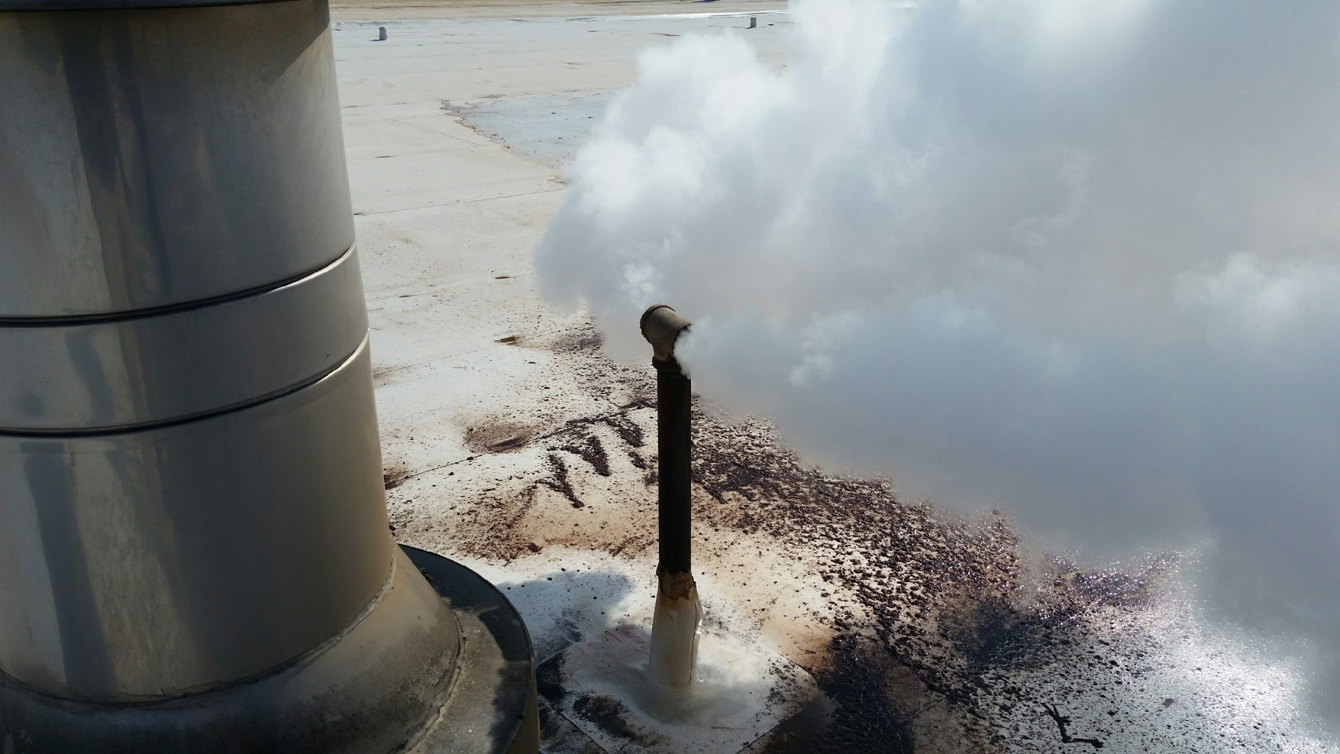

United Cocoa
  - Energy audit

UD EPA P2 Center

February 4, 2020
On February 28, 2019, the University of Delaware Industrial Assessment Center, under a grant from the EPA Pollution Prevention program, performed an energy, water, and waste reduction audit for United Cocoa Processors, Inc., in Newark, Delaware. Three students contributed, providing hands-on training to their overall engineering education.

The 93,000 ft2 plant manufactures cocoa liquor, presscake, and fine cocoa powder from cocoa beans after roasting. The roasters are heated with steam coils using 100 psi steam from gas fired boilers. The boilers also supply steam to 3 heat exchangers to produce hot water, which is used to heat process tanks.

Plant electric consumption is 4,084,870 kWh/year, 19 % by the powder mills.
Plant gas consumption is 31,118 MMBTU/year, 98 % by the boilers.
Plant water consumption is 2,088,000 gallons/year, 36 % makeup water for the boilers.
Plant existing Best Practices include good insulation on process tanks and some LED upgrade.
9 recommendations were made that would reduce water consumption by electric consumption by 15 %, gas consumption by 17 %, water reduction by 25 %, and carbon dioxide reduction by 16 %. 4 recommendations are in-progress at the date of this report, 2 are planned, and 2 are rejected for operational reasons.
Prof. Keith Goossen, 107 Evans Hall, Newark DE 19716, goossen@udel.edu, email for a free audit at your plant today!

United Cocoa  - Recommendations |  | The recommendations are color coded: green means implemented or in-progress, blue means planned, black means still under consideration, red rejection. Recommendation 3 was rejected because operationally too difficult to manage multiple heat sources. Recommendation 4 was rejected for inside air quality reasons.
1  Utilize flash steam for hot water, saving 1,878 MMBTU gas/year and 530,000 gallons/year water  2  Preheat boiler makeup water with stack economizer, saving 731 MMBTU gas/year  3  Replace steam exchanger heated hot water with condensing hot water boiler, saving 2,472 MMBTU gas/year  4  Route powder mill intake vents to outside, avoiding venting cooled room air, saving 70,400 kWh/year  5  Insulate steam header pipes, saving 177 MMBTU gas/year  6  Insulate process tank legs, saving 49 MMBTU gas/year  7  Include variable speed fan drives on the new cooling towers, saving 43,600 kWh/year  8  Upgrade production lighting to LED, saving 474,680 kWh/year  9  Upgrade office lighting to LED, saving 11,140 kWh/year | Implemented (including in progress) results  Electric savings = 485,820 kWh/year (additional 43,600 planned)  Gas savings = 2,055 MMBTU/year (additional 731 planned)  Water savings = 530,000 gallons/year  Recommendation 1 discussion  The steam system produces significant flash steam as high pressure condensate enters the condensate tank. This does not appear to be a fault of the steam traps but rather is normal for the steam system operation. The low-pressure flash steam was estimated at 530,000 gallons/year or 70 % of measured makeup water. It was recommended to use this low pressure steam in one of the heat exchangers to produce hot water, replacing boiler steam, saving 1,878 MMBTU/year and 530,000 gallons/water then returned to the boiler rather than vented into the atmosphere as steam. Upon being presented with the recommendation, plant personnel chose to capture the flash steam in a tank for hot water instead, which is a better idea since the gas savings is increased by the avoidance of heat exchanger losses. This illustrates a dynamic of the energy audit process, that sometimes recommendations from our study prompt additional study and so serve as the catalyst for amplified savings.  Recommendation 4 discussion  The powder mills are cooled with about 16,000 cfm room air, causing significant negative pressure in the room. This causes outside air infiltration and additional air conditioning costs in the summer, that could be avoided if the mill vents were ducted outside. Plant personnel rejected this measure as it would place undo filtration issues on the incoming air. This illustrates how during the one-day audit, every possible practical energy, water, and waste reduction measure is pursued, to provide the plant with all options, which sometimes upon further study are determined not viable. About 15 % of our recommendations are rejected which is a good number showing our pursuit and dedication to finding all possibilities.

