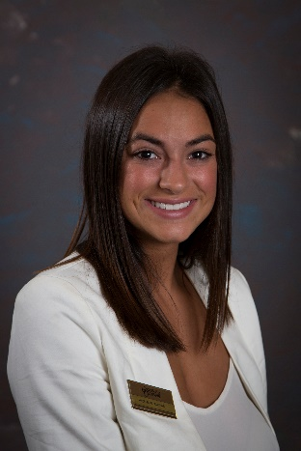
Madeleine Bouchard
Comments about Madeleine's performance were so complimentary about her confidence and sense of teamwork. She was "ready to jump in, seems comfortable at the desk and on phones; worked as a team to balance house accounts." Furthermore, she shined on her P.M. Front Desk shift by taking the initiative to check and make sure group billing was set-up correctly. Way to go Madeleine!

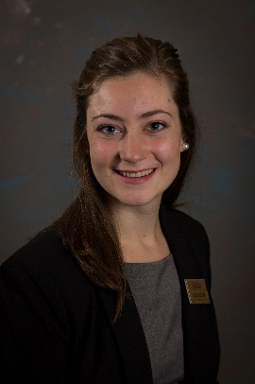

Alice Ritschard
Alice was "more than exceptional" during her Front Desk rotation. Hotel staff noticed that Alice answered phones off the bat, and was able to help with reports with little instruction - you could tell she had prior hotel experience; she knew just about everything and we could hire her tomorrow!

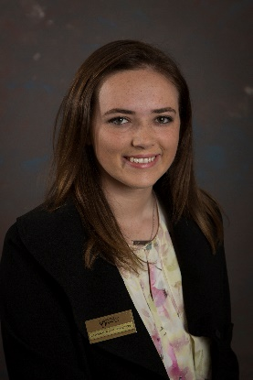

Katie Burke-McGoldrick
Katie was eager to learn and was very flexible in regards to switching between different tasks throughout the shift. She was very positive and had a great attitude. Additionally, she showed great competency with the Front Desk computer system and was phenomenal with guests. Congrats Katie!

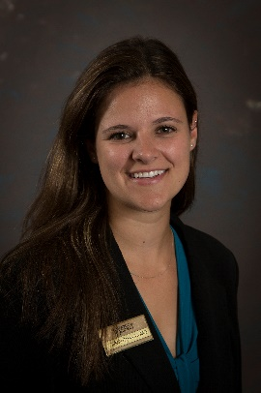

Samantha Cuomo
Infectious energy! Sam helped with additional projects and made it her mission to get to know the guests. She was very cheerful and learned the Front Desk very quickly. Her questions were on-point and you could tell, she's in it to win it!

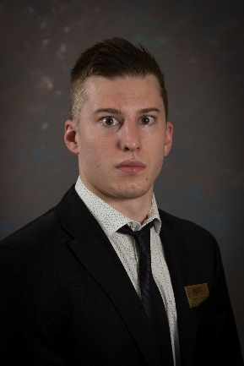
Tyler Dekleva
Tyler received three separate nominations and countless verbal comments from a variety of hotel staff. All of them raved about how much of an All-Star he is! He was "an amazing help at the Front Desk, Sales (setting up group routing), Bistro (serving food and bussing tables), & Housekeeping (delivering guest items). One of the night's Tyler was working, it was the "busiest shift I have seen in a long time & Tyler never flinched". All-star job. Event when desk pace slowed, offered to help Bistro. Super professional and always willing to jump in and help whoever needed it! Kudos!

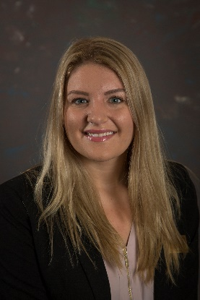
Julia Bonadonna
Two staff members offered praise for Julia’s contributions over the last several days. First, during her Night Audit shift, Julia was said to have “many assets – smart, talents, and verbose.” She asked great questions and gave good effort. Many thanks to her for the “scratch sheet” she made for other interns. Next, while serving as Manager on Duty, Julia was all about teamwork and offered help to nearly everyone she encountered. She helped clear tables in the Bistro and Bar, she helped the Front Desk with students, and she took the initiative to help a guest with a special request. Kudos Julia!

