Key Concepts in Community Engaged Scholarship for Health

Introduction
The UD Partnership for Healthy Communities envisions healthy, thriving communities for everyone in Delaware and beyond, with a particular focus on communities that experience health inequities. We work to advance this vision by strengthening the University’s capacity for community engaged scholarship. We define community-engaged scholarship for health as:
The generation and application of knowledge through the synergistic activities of teaching, research and service in authentic partnership with a variety of community stakeholders, eliminating traditional hierarchies and one-way flows of knowledge outward from the University; it prioritizes interdisciplinary collaboration and mutually beneficial, sustainable partnerships which enhance the capacities of the university and its community partners to address critical health needs.

Research
Community engaged research is characterized by the discovery or creation of new knowledge or insights in collaboration with community partners and/or to address community needs. Examples of community engaged research include but are not limited to (MSU, n.d.):
- Community-based participatory research (CBPR) or participatory action research (PAR)
- Applied research or translational research
- Contractual research (funded by government, non-governmental organizations, or businesses) to meet specific policy or practice needs
- Demonstration projects
- Needs and assets assessments
- Policy analysis and program evaluations

Teaching
Engaged teaching/learning is characterized by the sharing of knowledge with various audiences through either formal or informal arrangements that prioritize application of knowledge to community-identified needs or opportunities; or by teaching/learning that occurs in the community or in the field. Engaged teaching may be for-credit or not-for-credit, guided by a university instructor, community member, or self-directed. Examples of community-engaged teaching/learning include but are not limited to:
- Community-based learning such as internships or professional practica that occur directly in the community
- Service-learning courses or learning activities that engage students in the community in ways that provide a “service” to address a community need and enhance the students’ learning of course content in the process
- Study abroad programs with community engagement components
- Community-based capstone experiences that often have a strong research or service component and are directly related to or occur in the community
- Pre-college programs for youth in K-12 or post-secondary/professional certificate or licensure programs
- Conferences, seminars, not-for-credit classes, and workshops, including educational enrichment programs for the public and alumni

Service
Engaged service is associated with the use of university expertise to address specific issues or needs identified by individuals, organizations, or communities (MSU, n.d.) external to the University. This type of engagement is generally not driven by a research question, but rather designed to provide a genuine service to the community or in partnership with the community. Community engaged service is not the same as traditional academic service such as serving on a departmental curriculum committee or university-wide promotion and tenure committee; but may include serving on an external advisory board or community coalition. Examples of community engaged service include but are not limited to:
- Providing technical assistance or consulting to community groups or organizations
- Conducting policy analysis or providing expert testimony in a legislative hearing
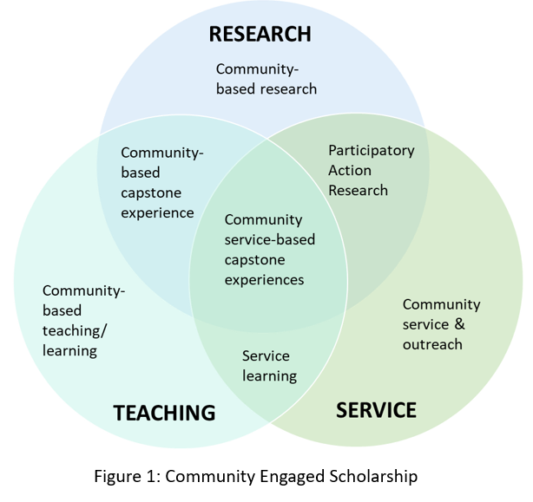
- Service in the health professions may include clinical practice or diagnostic services provided free of charge to communities in need.
- Participating on advisory boards and other disciplinary-related service to community organizations

As our definition of community engaged scholarship implies, the greatest impact generally occurs at the intersection of community engaged research, teaching/learning and service because of the opportunity for mutually reinforcing benefits. Figure 1, adapted from CCESHP, 2005 and Furco, 2010, illustrates the overlap of the traditional elements of scholarship within higher education adapted to highlight some examples of opportunities for community engagement outlined above. Importantly, these are only examples, and there are many other kinds of opportunities for such intersection.
Principles & Values of Community Engagement Scholarship for Health
Community engaged scholarship for health recognizes not only the value, but the necessity, of authentic partnerships to dismantle traditional hierarchies that contribute to health inequities and engage in partnerships that promote population health. Values of community engaged scholarship, in addition to institutional standards of rigor and quality, have a distinct emphasis on authentic partnerships, which have been characterized by the following four elements (CCPH, 2013):
- Guiding Principles of Partnerships: are collaborative, sustainable, involving a deep sense of trust, shared power and resources, and mutually beneficial (see CCPH for detailed descriptions).
- Quality processes: are relationship focuses; open, honest, respectful, ethical; acknowledging of history; and have a commitment to mutual learning and shared credit.
- Meaningful outcomes: are tangible and relevant to communities.
- Transformative experience: on multiple levels including personal, institutional, community-level, knowledge-based, and political.

Purpose of Community Engaged Scholarship for Health
When conducted in a thoughtful and authentic manner, community engaged scholarship serves a number of purposes for the enrichment of the university, community; and their ability to more effectively address complex social issues related to health.

Vision:
Value to the university:
Engages students in a high-impact practice (Kuh, 2008) that supports their learning, and increases the number of graduates with community health-related skills, expertise and commitment upon graduation.
With an increasing emphasis on addressing community issues, which most often require interdisciplinary work, greater funding opportunities are available for faculty and staff collaborating with one another and with their community partners (Stanton, 2008).
Increases the university’s capacity to respond to community health needs, and thus increases the value and reputation of the institution from the perspective of the community.
Value to the community:
Improves the capacity of community partners to respond to health needs; a product of the increased resources available through university-partnerships (e.g. policy briefs, workshops, program evaluations, etc.) (Pasick et al., 2010).
Increases the investment in and better alignment of sustainable resources for community health (Pasick et al., 2010).
Improves the overall experience of community members in collaborating with the university and local residents’ interest in having the university as a citizen of their community.
References & Additional Resources
Campus-Community Partnerships for Health https://www.ccphealth.org/
Campus Community Partnerships for Health [CCPH] (2013). CCPH Board of Directors. Position Statement on Authentic Partnerships. Community-Campus Partnerships for Health, 2013.
Commission on Community-Engaged Scholarship in the Health Professions [CCESHP]. (2005). Linking Scholarship and Communities. Seattle, WA: Community-Campus Partnerships for Health.
Furco, A. (2010). The engaged campus: Toward a comprehensive approach to public engagement. British Journal of Educational Studies, 58 (4), p375-390.
Jordan C (Editor). (2007). Community-Engaged Scholarship Review, Promotion & Tenure Package. Peer Review Workgroup, Community-Engaged Scholarship for Health Collaborative, Community-Campus Partnerships for Health. https://depts.washington.edu/ccph/pdf_files/CES_RPT_Package.pdf
Kuh, G.D. (2008). High-impact educational practices: What they are, who has access to them, and why they matter. Washington, DC: Association of American Colleges and Universities.
Michigan State University, Outreach and Engagement https://engage.msu.edu/about/overview/common-types-of-community-engaged-scholarship-reported-by-faculty
Pasick, R., Oliva, G., Goldstein, E., & Nguyen, T. (2010). Community-engaged research with community-based organizations: A resource manual for UCSF researchers. From the series: UCSF Clinical and Translational Science Institute (CTSI) Resource Manuals and Guides to Community-Engaged Research, P. Fleisher, Ed. San Francisco, CA: Clinical Translational Science Institute Community Engagement Program, University of California San Francisco.
Stanton, T.K. (2008). New times demand new scholarship: Opportunities and challenges for engagement at research universities. Education, Citizenship, and Social Justice 3(1), 19-24.
University of South Florida, Office of Community Engagement and Partnerships https://www.usf.edu/engagement/faculty/community-engaged-scholarship-toolkit.aspx

Adapted from “Community Engaged Teaching and Learning” section at University Outreach and Engagement at Michigan State University. See reference for more details.
We believe there may be additional value to both the university and the community in conducting community engaged scholarship, but will refine this list after listening to our community partners.

