Delaware 4-H Legislative Day

This is an annual event where 4-H members can visit our State Capital to learn what the legislative process is all about! 4-H’ers can participate in Legislative Day for more than one year as we offer different programs for different year’s participants

Please register me for the 2023 Delaware 4-H Legislative Day scheduled for Wednesday, April 26. There is a $10.00 fee for lunch that will be provided. Cash and check payment can be dropped off to any county 4-H office. Checks should be payable to the ‘University of Delaware.’ (Sorry, no refunds.)

Name: ________________________________ County: ___________________

Address: ______________________________ Age: ______ (must be 8 years of age
______________________________ and older to attend)

Phone number: _____________________ E-mail: ____________________________

4-H Club Name: ___________________________________________

If you have attended 4-H Legislative Day previously, please indicate which of the following workshops you have participated in at this event:

____ Legislative Hall Session with Legislator ____ Tour of Legislative Hall
____ Department of Education Workshop ____ Superior Court Workshop
____ Public Archives Workshop ____ How a Bill Becomes a Law Workshop

Please indicate the following: State Representative _________________________
State Senator ________________________________
Do you have examples of project work that you could bring to display so that legislators understand what 4-H is all about? (Example: birdhouse woodworking project, photographs, pillow, or garment you have sewn, etc.)

Check one: ____ Yes ____ No I will be bringing ______________________________________

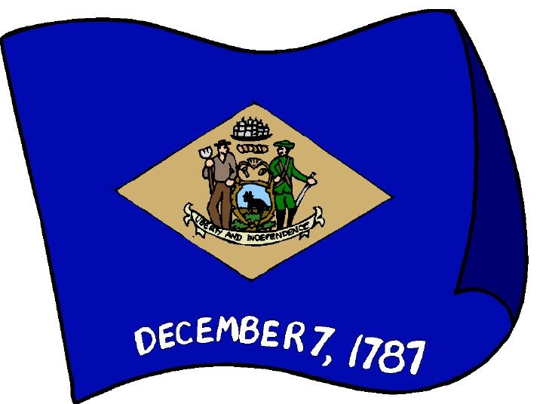
Return Completed Registration by April 17:
DE 4-H Legislative Day
c/o Kaleb Scott
16483 County Seat Hwy.
Georgetown, DE 19947

