DELAWARE 4-H

STATE NEWS

Camp Barnes 2022

Contents:
STATE 4-H CAMPS...  A Letter from your  State 4-H Program Leader | 1
CAMP POLICY  - Code of Conduct  - Cell Phones  - Mask Wearing  - Scholarships | 2
SO YOU WERE WONDERING  - What if camp is full?  - What is the refund policy?  - What does the camp fee cover?  - Where will I stay?  - What is the early dismissal policy for the weeklong camp?  - May I have a friend visit?  - Can I bring medicine?  - Delaware 4-H Foundation | 2
LINKS TO: REGISTRATION FORMS HEALTH FORM  CAMP PHOTOS | 3

A Letter From Your State 4-H Program Leader
SUBJECT: Weeklong 4-H State Camp and Environmental Camp - MODIFIED CAMP THIS YEAR
With plans ongoing for an in-person 2022 Delaware 4-H State Camp and State Environmental Camp experience, we felt it important to share the following revisions to the attendance policy in light of in- person safety restrictions and compliance with State and University of Delaware health guidance.
- Any camper who attended Delaware 4-H State Camp previously, either virtually or in-person, is eligible to register for Delaware 4-H State Camp in 2022.
- Any youth who are 11 years old (as of June 1) or older may apply to attend State Camp in 2022.
- All 10-year-old youth will not be able to apply to attend the weeklong 4-H State Camp, but we strongly encourage them to apply and attend the State Environmental Camp in 2022.
Weeklong 4-H State Camp (11-19 years old—Open to RETURNING campers and first-year campers 11 years old and older):
- The date for WEEK 1 is June 13-18 and WEEK 2 is June 20-25. This camp officially starts with lunch
on Monday and ends after breakfast on Saturday.
- State 4-H Camps (Week 1 and Week 2) are held at Camp Barnes located in southeast Sussex County
on beautiful Miller’s Creek.
- You will be assigned to a people group for afternoon and campfire activities.
- Bus transportation will be available for New Castle and Kent County campers.
- This year’s camp fee will be $375.00. (Note: The change in fee is the result of increased per camper
fees that will be assessed to Delaware 4-H by Camp Barnes due to the current COVID situation.)
State Environmental Camp at Camp Barnes (8-12 years old):
- This is an experience you won’t want to miss that allows you to explore basic soil and environmental science information. Getting your hands dirty, exploring the forest, and looking for critters was never so much fun.
- The date for this camp is June 10-12. Camp officially starts at 3:00 p.m. on Friday, June 10. Camp will conclude at 10:00 a.m. on Sunday, June 12.
- A variety of classes related to the environment will be available for your participation, and classes are taught by University of Delaware undergraduate and graduate students. Previous camp
classes have included topics such as “Is River Water Safe to Drink? and “Digging Up the Dirt on Soil Microbes.” New classes are added each year. Each afternoon provides time for recreation, such as swimming and canoeing. You will be assigned to a group for afternoon and campfire activities.
- Bus transportation will be available for Kent and New Castle County campers.
- This year’s camp fee will be $145.00. (Note: The change in fee is the result of increased per camper
fees that will be assessed to Delaware 4-H by Camp Barnes due to the current COVID situation.)
How to Register for Camp:
Registration opens April 1 (10 a.m.) for “ACTIVE” 4-H MEMBERS
There are two ways to register for camp—online at www.udel.edu/009245 or paper form (attached).
If registering online, you must pay the full amount either by credit card or check. If registering by paper form, the entire camp fee is required to accompany your application. A health form is mandatory for this camp. 4-H members are required to update their health form at 4-H Online.
If you have any additional questions about 4-H State Camp, contact your local county 4-H office (New Castle: 302-831-8965, Kent: 302-730-4000, Sussex: 302-856-7303) or the State 4-H
Office at 302-831-2509. Camp scholarships may be available to enrolled/active 4-H members through your county 4-H office.

I pledge
My head for clearer thinking, My heart for greater loyalty, My hands to larger service, and My health to better living,
For my club, my community, my country, and my world

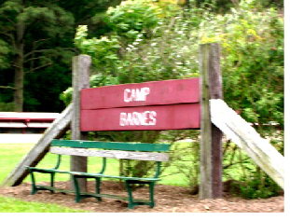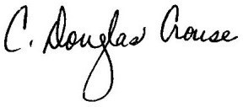C. Douglas Crouse State Program Leader 4-H Youth Development

DELAWARE 4-H Page 2
Camp Policy

Code of Conduct Violations

Anyone breaking the Code of Conduct during the 4-H year will not be put in a leadership role at State 4-H Camp. If the offense is severe enough, the 4-H’er will not be allowed to attend State 4-H Camp.
So you were wondering...

What if camp is full?

If the week of camp you have chosen is full when you apply, you will be given the opportunity to go to the other week, space permitting. If both weeks are full, you may go on the waiting list. If camp slots open or the total camp capacity is approved to be increased, campers will be moved off the waiting list.

What is the refund policy?

Cancellations for a verified emergency will received a r e f u n d ( mi n u s $ 25 administrative fee ) up to June 1. No refunds will be issued after this date.

May I leave camp?
You must attend camp full time. The exception is a family emergency.

Cell Phone Policy

Cell phones are not permit- ted at camp. The use of cell phones has become a distraction and takes away from the ability of campers to stay focused on camp. Any camper that brings a cell phone to camp will be required to turn in their phone on Monday morning at registration, and it will be returned on Saturday morning at dismissal.

What does the camp fee cover?
The registration fee includes the camp photo, class costs, snacks, meals, and lodging.

What is the early
dismissal policy?
Normal dismissal time for weeklong camp is 10 a.m. No one may leave camp until 5 a.m. on Saturday morning. Any exception must have prior approval of the camp staff.

ANY SPECIAL DEPARTURE REQUESTS SHOULD BE MADE WITH THE STATE 4-H OFFICE ONE WEEK PRIOR TO THE START OF CAMP. APPROVAL MUST BE GRANTED BY THE CAMP
STAFF.
WILL I HAVE TO WEAR A MASK?

In the ever-changing environment, we will follow the University of Delaware guide- lines, and all camp- ers, counselors and staff will be required to follow as well
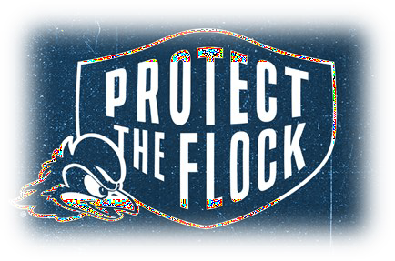

Where will I stay?

You will sleep in cabins of 7-8 campers, including a counselor. A central bath facility is nearby. All meals are served cafeteria style, and there is also a canteen for snacks. A variety of classes are available for your participation. Each afternoon provides time for recreation, such as swim- ming and canoeing. You will be assigned to a group for afternoon and campfire activities.

Scholarships

Each county will collect camp scholarship applica- t i ons begi nn i ng o n January 1. All scholarships will be awarded prior to April 1 and recipients notified. Each club and county is encouraged to obtain local funds to make participation in the over- night State 4-H Camps a possibility for every 4-H member.

May I have a friend visit?
Please do not invite anyone to visit you at any time during camp. Our camp is closed to all visitors during the week.

Can I bring medicine
to camp?
Yes, prescribed and over- the-counter medicines must be turned in upon arrival at camp in the original con- tainer with the camper’s name printed on the bottle. See page 4 for Mandatory Camp Medicine Form.
DELAWARE 4-H FOUNDATION

The Delaware 4-H Foundation offers one $25.00 scholarship per family with two or more children attending overnight 4-H camp.

In addition, the Delaware 4-H Foundation provides
$3000 in scholarships to qualifying enrolled/active 4-H members in the counties to support attendance.

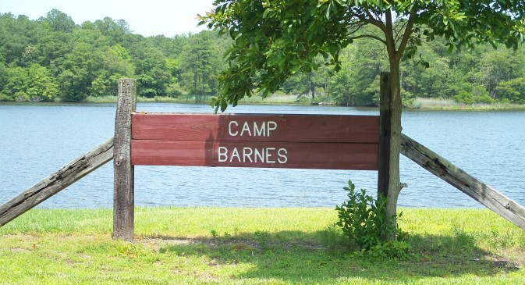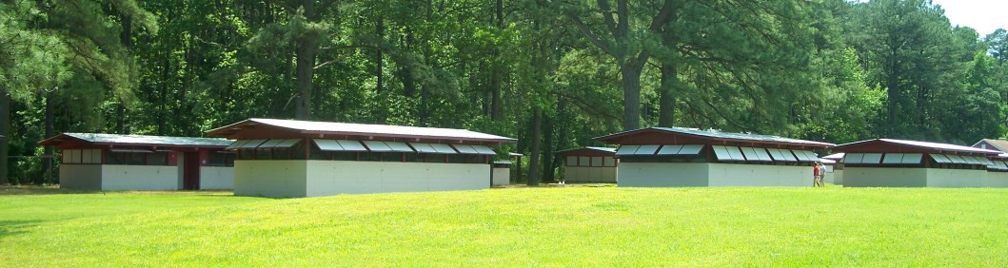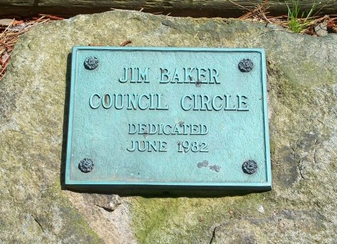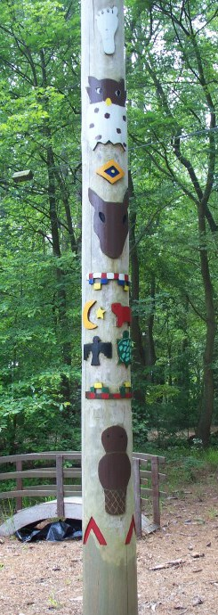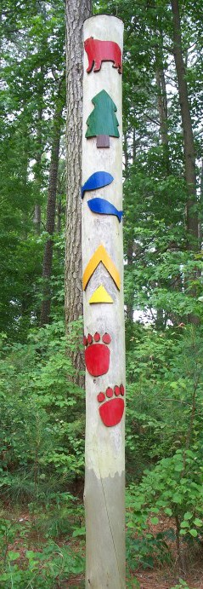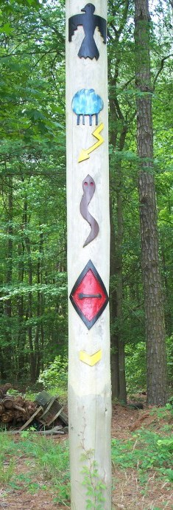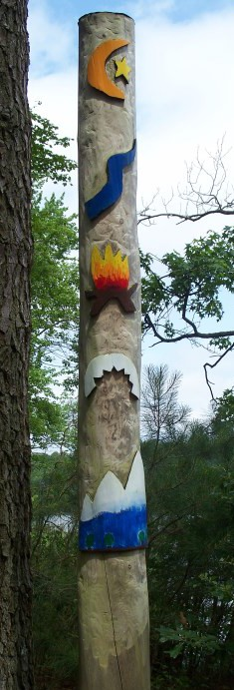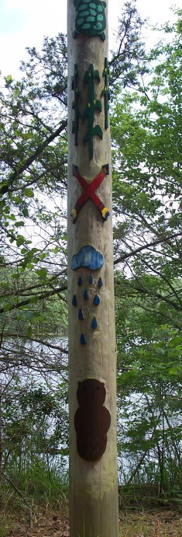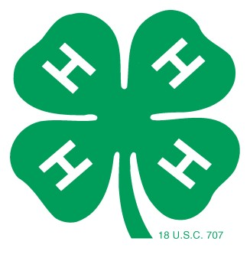
Come and make a memory at 4-H State Camp!
Click for:
ONLINE ENROLLMENT FORM HEALTH FORM MEDICINE FORM
4-H State Camps webpage Past photos from state camps:
Environmental Camp
Week 1 State Camp ~ Week 2 State Camp
Questions about camp may be directed to your local county 4-H office or the State office.
New Castle: 302-831-8965 Kent: 302-730-4000 Sussex: 302-856-7303 State: 302-831-2509

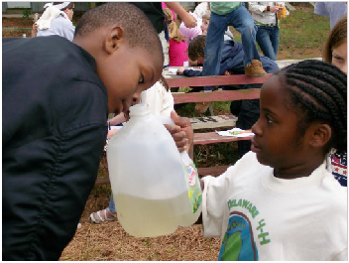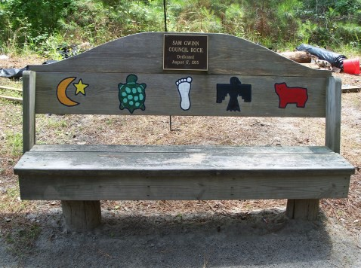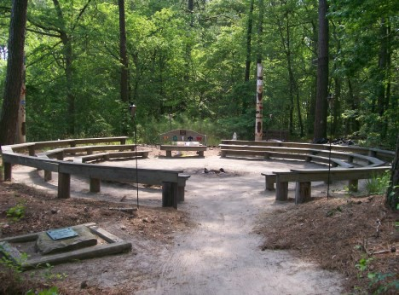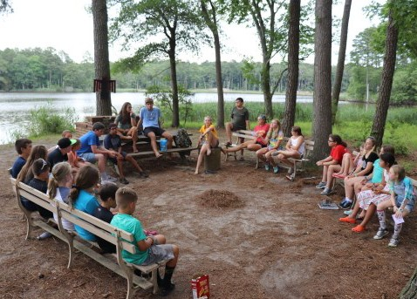“Cooperative Extension Work in Agriculture and Home Economics, Extension Service, University of Delaware and United States Department of Agriculture, cooperating. Distributed in furtherance of Acts of Congress of May 8 and June 30, 1914. It is the policy of the Cooperative Extension Service, University of Delaware that no person shall be subjected to discrimination on the grounds of race, color, sex, disability, age, or national origin.”

Environmental Campers

2022 Delaware 4-H State Camps Registration Form
Camp Dates: (CIRCLE ONE)
June 10-12 (Environmental Camp) ~ June 13-18 (Week 1) ~ June 20-25 (Week 2)

Registration opens April 1 for active 4-H’ers. You may register for camp online at www.udel.edu/009245 or mail a paper registration form with your check to the State 4-H Office. If you register online, you may pay either by credit card or check. If you register by paper form, the entire camp fee is required to accompany your application.
IMPORTANT: With plans ongoing for an in-person 2022 Delaware 4-H State Camp and State Environmental Camp experience, we felt it important to share the following revisions to the attendance policy in light of in-person safety restrictions and compliance with State and University of Delaware health guidance.
  - Any camper who attended Delaware 4-H State Camp previously, either virtually or in-person, is eligible to register for Delaware 4-H State Camp in 2022.
  - Any youth who are 11 years old (as of June 1) or older may apply to attend State Camp in 2022.
  - All 10-year-old youth will not be able to apply to attend the weeklong 4-H State Camp, but we strongly encourage them to apply and attend the State Environmental Camp in 2022.

Name: (first (last) Age on 6/1: Date of Birth:
Gender: M—F

Address: (street)
(city)
(state)
(zip)

Parent/Guardian Name (with whom the camper presently lives):

Parent Phone Numbers:

Other Contact (if parent unavailable):
_ Phone Number:

Special needs that should be considered in planning camp (this includes dietary restrictions, ADHD, etc.):

Parent EMAIL Address: Are you a first-year camper? Yes / No
Club/Afterschool name (if applicable): What county is your club in? NCC / Kent / Sussex
Delaware 4-H State Camp is provided to all youth without regard to race, color, sex, disability, age, or national origin. Ethnicity is
requested for reporting purposes only to USDA. Circle one: HISPANIC ~ NOT HISPANIC

If you’ve been to a Delaware 4-H State Camp before, to what “people group” do you belong?
Delaware 4-H State Camp is provided to all youth without regard to race, color, sex, disability, age, or national origin. Ethnicity is
requested for reporting purposes only to USDA. Circle one: HISPANIC ~ NOT HISPANIC
Circle ALL that apply: White ~ Black ~ Am Indian/Alaskan Native ~ Asian ~ Hawaiian/Pacific Islander

Bus transportation will ONLY be available for New Castle and Kent counties. If you require bus transportation, please circle a stop below:
- NCC Ext. Office (Newark) • Kent County Ext. Office
- People’s Plaza • Milford (Sitel site, 999 N. DuPont Blvd.)

State 4-H Camp Registration Fee: $375
Enter your registration fee here: | $
Scholarship Award (subtract): - | $
Subtotal: | $
Sibling Discount (subtract $25): - | $
BALANCE DUE | $

Environmental Camp Registration Fee: $145
(price for all camps includes meals, lodging and picture)

  - If a family has more than one camper attending one of the above camps, please deduct $25 from the registration fee

Environmental Campers ONLY Youth T-shirt size: (circle one)

Small ~ Medium ~ Large ~ X-Large

(one scholarship per family). My sibling(s) are:

  - I am entitled to an additional scholarship of $ .
My letter or certificate of proof is enclosed with this application.
Make check payable to University of Delaware and send full balance due to the address below.
******* Write camper’s name on check *******
Cancellations for a verified emergency will receive a refund (minus $25 administrative fee) up to Wednesday, June 1.
No refunds will be issued after this date.

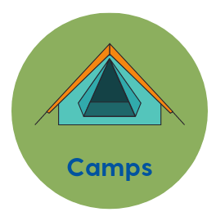
University of Delaware, State 4-H Office, 113 Townsend Hall, 531 South College Avenue, Newark, DE 19716-2210

