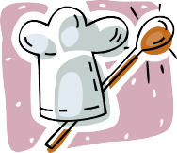

The 4-H Favorite Foods contest is a contest open to all 4-H members currently taking any foods, bread, food preservation or Exploring 4-H project. The reasons for holding this activity are:
Newsletter Date

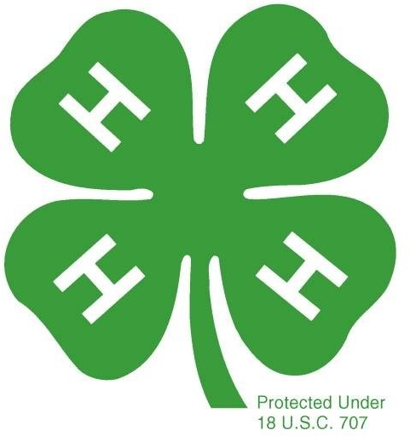

FOODS
- Increase knowledge of the importance of good nutrition and create an interest in improving food standards.

- Help 4-H club members improve skills in food preparation and display.

- Encourage originality, creativity, initiative and poise in the 4-H member.

- Develop wholesome attitude, character and personality traits.

Member prepares dish at home and brings it and a place setting to the con- test site.
AGE DIVISIONS

Cloverbud: Ages 5-7 (note special requirements) Junior: Ages 11-13 Beginner: Ages 8-10 Senior: Ages 14-19
D E L A W A R E 4 - H
FAVORITE

RULES

The following general rules apply to all contest participants.

  - Recipe must be suited to the age and project of the contestant. Older 4-H’ers or more experienced 4-H’ers will be expected to prepare more challenging dishes.
  - Participants must do all the food preparation,
cooking and table setting with limited help or guidance.

  - Recipe should serve four to eight persons.
  - Finished food will be displayed at a place setting for one person:
    - Space provided is
approximately 29" wide

x 29" deep.
    - It is suggested that you use available or borrowed dishes, glasses, flatware, etc.

    - Crockpots can be used to transport and keep food warm.

5. Beginners do not have to use a range or appli- ance.

- Time will be provided to allow contestants and parents to view and photograph the place settings after the announcements of winners. This year there will NOT be any tasting of dishes. At the conclusion of your child being judged they are able to pack up their items once they have taken a picture.

FOOD CATEGORIES

BREADS - (Batter or yeast breads). Any type of bread, may be yeast or dough or batter; may be sweet, such as coffee-cake types or plain, such as loaf bread or sandwiches. Coffee rings, nut or fruit breads and rolls can be included here.

MAIN DISH - Any food used as an entree in the meal. This can include a meat, soup or another protein option. Each serving normally contains two ounces of meat or the equivalent of a meat substitute. Examples include lima bean and ham casserole, ham and cabbage or broccoli and tuna casserole.

SIDE DISH – Any dish you would consider a side dish. Fruits, vegetables, rice, or pasta. You might consider entering a broccoli and rice casserole, baked pineapple, green beans and mushroom casserole, stewed tomatoes or three-bean salad.

COOKIES, CUPCAKES AND BROWNIES - For Cloverbuds and Beginners only.

DESSERT - Any food item other than cookies, cupcakes or brownies that you would use as a dessert.

APPETIZERS - Appetizers, are usually not served with the main dish. Appetizers are

Your Favorite Food Entry can come from any of these categories!
served prior to the main course, usually at the table setting. This can include a soup if
served before the main dish.

**BREAKFAST CASSEROLE - Any food item that you would make for your family to eat at breakfast.

**This category will change every two years to add a new component to the contest

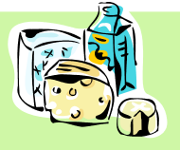

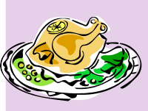

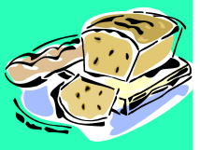

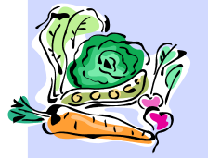

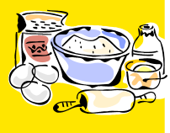

SELECTING THE RECIPE

Make sure your recipe is easy to read. It will be copied into the Favorite Food Cookbook

RECIPE AND MENU PLANNING
Select a recipe that involves an unusual ingredient, imaginative garnish or
method of preparation instead of a basic recipe. For example, prepare herb-fried chicken instead of fried chicken; or add orange extract or chopped nuts to a basic yellow cake to give a new flavor.

RECIPE WRITING - List all

ingredients in order of use and then write

out the instructions in order of

preparation. You may want to number

the directions to clarify when to do a step. Include temperature and number of

servings.

MENU - Menu plans should be well balanced nutritionally. These plans should be written in the logical order of service as well as being attractive in appearance. The menu must be planned by the 4-H member and MUST be a menu that can be prepared by the 4-H’er. Below is a sample of how to write a menu:

PLACE SETTING - The size 29” x 29”

is approximate. The tables may vary. You will set the place setting for one person. The table setting should only include the utensils/ dishes you need to consume the dish prepared for the contest. You may choose to add a centerpiece following a theme of your place setting, the food or whatever you choose. Refer to the information on table service on page 4 and 6 for further help.

BASIC MENU PATTERN

Appetizer Main Course
Vegetables Vegetables Salad
Bread Dessert Beverage

The above sample can be followed for all meals; however, you may leave out parts
that do not fit. For example, no vegetables would be served for breakfast. If a line in your menu is not balanced, then the item should be placed in the center of the line.

Cloverbud members are required to provide a recipe and place setting. Menus are not required.

Remember: Neatness Counts!

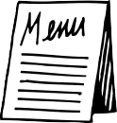
THE MENU
HOW YOU WILL BE SCORED BY THE JUDGES
  - Nutritionally Well-Planned/Balanced or Planned for Special Diet - Should include a variety of food and colors from all major food groups. Example: Not all meats or vegetables; not all green
vegetables or all vegetables in sauces, but a variety of types.
  - Texture, and Contrast - Not all crunchy or all soft, but a variety.
  - Color Contrast - Use different color tones. Not all browns, reds, etc.
  - Flavor Contrast - A variety of flavor contrasts. Not all spicy foods or all bland, but a mixture.
  - Correctly Written - See example.
  - Age Appropriate for Preparer - Select a menu that is appropriate for participant. Age and skill must be considered. A senior menu and recipe selection should include multiple steps and methods as appro- priate.

THE RECIPE
1. Correctly Written - Ingredients first, then instructions. (List both in order of use).

FOOD PREPARED
- Eye Appeal - Does the dish look tempting and good?
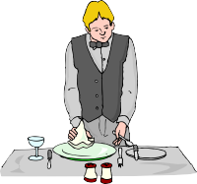

- Flavor - How does it taste?
- Seasoning - Too much or too little of any ingredient?
- Texture - Is it tough or tender, falling apart or too juicy, etc.?
- Properly Cooked - Overdone or under done or perfect?
- Degree of Difficulty - Does the recipe fit the ability of the participant, not too easy, but a challenge?

TABLE SETTING
  - Overall Neatness
  - Proper Placement of Utensils - Use only necessary utensils, place in proper spot. Use only necessary tableware for the dish you have prepared.
  - Attractive Total Effect - Do all the items on the table look attractive when placed together?
  - Appropriate Decorations - Do not use arrangements that may fall into food or take away from the food. The food should be the main attraction. Centerpieces should be suitable for the space provided.

ATTITUDE OF CONTESTANT
- Positive Attitude/Friendly - Contestant politely responds to questions from the judge.
- Appropriate Outfit - Dressed to participate in a foods contest, no jeans or sweats.
- Knowledge of Dish Prepared - Contestant should be knowledgeable of all parts of the contest.
Ex: If the contestant doesn’t know how to make scalloped potatoes, it should not be part of the menu.

Remember, A SMILE WORKS WONDERS!

TABLE SERVICE
Here are some helpful hints regarding table settings for the Favorite Foods Contest. Remember, your place setting should be just for the course you are preparing for the contest.
**Place main plate, flatware and napkin in a straight line one inch from the edge of the table**

MAIN DISH CATEGORY
  - Fork, knife, dessert fork or spoon.
  - No spoon unless coffee was served during the main course or if Stew or Chili is the main dish.
  - The soup bowl and plate are placed on the dinner plate and then removed for the main course. A
soup spoon is placed to the far right of the knife because it will be used first.
  - No salad fork unless you wanted to be very formal and even then you would probably serve the salad as a an appetizer. (If a salad is served during your main course, it is acceptable to eat it with your regular fork.)
APPETIZER CATEGORY
- To serve an appetizer at the beginning of your meal, place the plate in the center of your dinner plate and the appropriate fork or spoon on the side to which it belongs. The menu for this setting includes soup served as an appetizer and a salad served with a meal. A soup spoon is placed to the far right of the knife because it will be used first.

BREAKFAST CASSEROLE CATEGORY
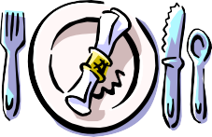

  - Fork, knife or spoon.
  - No spoon unless coffee was served during breakfast

DESSERT CATEGORY
  - If your entry is a pie or cake where a dessert plate is required, the only other piece of silverware might be a spoon for coffee or tea.
  - If coffee is served, your dessert fork goes to the left of the dessert plate and your spoon to the
right of the plate.
  - When no beverage is served, do not use the spoon unless it is needed. When there is no spoon,
place the dessert fork on the right. Leave your glass and/or cup and saucer and napkin on the
table.
BREAD CATEGORY
  - Your place setting might be one for a main course, dessert or a snack.
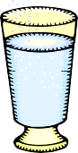

  - Just remember, forks go on the left and knives go on the right. Read the examples above if your bread entry is a main course or dessert.
  - A snack type bread or coffee cake type bread would be different. If served with butter, use a
dessert plate or bread and butter plate with a butter knife on the plate running parallel to the edge of the table. Jelly might also be served in the same manner. If both are served, you still only need to use one butter knife per person.

Glassware usually causes questions too. You must serve a beverage, as your menu reflects. If you want to be fancy and have one for water and one for milk, they should be arranged as used. Place the water glass at the tip of the knife. If milk, iced tea, or other drinks are served, place them to the right of the water glass and a little nearer to the edge of the table.

If coffee or tea is served with the main course, it is found to the right of the teaspoon with the handle parallel to the table edge. A water goblet may be at the same setting directly above the knife. If coffee is not on your menu until dessert, it is not correct to have an empty coffee cup sit there during the main course.

Since you will have a space of 29" by 29", your table covering can be anything (but PLEASE, don’t cut up your mother’s good tablecloth!!!). You can use any material you’d like to simulate a tablecloth. You may add a placemat to a table runner on top of the tablecloth.

Napkins traditionally are found with the fold to the extreme left and placed at the left of the fork. However, it is also correct to fold a napkin into a triangle and have the point to the left. It is correct to place the napkin folded in a unique manner and placed above the plate on the table or even in the water glass (empty of liquid, of course). Any of these are correct.

Please do not go out and spend a fortune on fresh flower for a centerpiece. There are so many other, more interesting items which can be used. Your imagination should really go to work. One year a contestant used cut up vegetables which she made to look like flowers in a miniature water can. How about a milk carton candle? Maybe you have an interesting seashell collection to use or a small piece of driftwood. Fruits, nuts, vegetables, dried flowers and leaves, a straw basket or interesting figurines all make fine centerpieces. One thing you should remember is to never have anything in the center or the table which you cannot see over. You will certainly want to see the person opposite you!

- Avoid clutter in your place setting...every item should have a use.

- You must include a beverage with your place setting, this could be water or another beverage.

- Be prepared to answer any questions the judges might ask you about your menu, place setting, food or recipe during the judging.

- Do not go out and buy new dishes or table linens; use what is available at home or share within your club.

- Use originality and your imagination for the contest...your score will be higher.

Here’s a hint for placing silverware:
Fork has 4 letters and so does left,
while knife and spoon both have 5 letters so does right!

TABLE SERVICE – Breakfast Place Setting

Bread Plate
Milk
Juice
Dinner Plate

Breakfast Menu
*Sausage, Egg, Vegetable Casserole
Whole Grain Toast

Napkin
Milk Tomato Juice

Breakfast Menu
Milk
Dinner Plate
Fruit Bowl
Oatmeal Bowl
Grapefruit Half
*Cinnamon-Raisin Oatmeal

Napkin
Blueberry-Banana Cup
Milk

* Indicates types of items you could make and use this place setting

TABLE SERVICE – Lunch Place Setting

Lunch Menu
Milk
Dinner Plate
Fruit Bowl
Soup Bowl
*Chicken Noodle Soup with Whole Wheat Crackers (on plate)

Napkin
Celery and Carrot Sticks
Chilled Grapes
Milk

Lunch Menu
Milk
Dinner Plate
**
*Turkey Vegetable Wrap Crispy Baked French Fries Crunchy Apple Slices

Napkin
Milk

* Indicates types of items you could make and use this place setting
** When only one utensil is used it is placed on the right side of the plate.

TABLE SERVICE – Dinner Place Setting

Dinner Menu with Soup as an Appetizer

Milk

Dinner Plate
Soup Plate Soup Bowl
*Clear Onion Soup Roast Turkey Breast Fragrant Sage Dressing

Napkin
Brussel Sprouts Mashed Potatoes
Spiced Baked Apple Slices
Milk

Dinner Menu with no Appetizer
Bread Plate
Milk
Salad Plate
Dinner Plate
*Barbecued Chicken Breast
*Skillet Zucchini Crispy Garden Salad

Napkin
*Chewy Yeast Rolls Milk

Dinner Menu with Salad as an Appetizer

Milk

Dinner Plate

Salad Plate
*Fresh Caesar Salad Sizzling Pork Chops and Onions
Green Beans Baked Potato

Napkin
Vanilla Ice Cream Milk

* Indicates types of items you could make and use this place setting
TABLE SERVICE – Dessert Place Setting

When Dessert is served on a plate

Milk

Plate

Napkin

When Dessert is served in a bowl

Milk

Bowl

Napkin

