County

Zip code:

2021 National 4-H Congress Application for Delaware

T-shirt size: S M L XL

Do you have any food allergies?

Number of sisters:

First name:

Grade on Sept 30:
Mother’s occupation:

PROJECT SUMMARY (Include all projects for all YEARS)
Race/Ethnic Group:

Statement by 4-H Member
I have personally prepared this report and certify that it accurately reflects my work and ideas. I agree to return to my club and county to implement a leadership project with the other National 4-H Congress delegates from Delaware.

Date: _______________________ Signature of 4-H Member: _________________________________________
Approval of this Report
Date: _______________________ Signature of Parent or Guardian: ____________________________________
Date: _______________________ Signature of Local 4-H Leader (not a parent): __________________________
Date: _______________________ Signature of County 4-H Agent: _______________________________
What career do you plan to follow?
Name of school:

Number of members:
Name of 4-H club or group:
Father’s occupation:
Number of brothers:
Mother’s name:

Father’s name:

Email:

Age Jan 1 this year:

Date of birth:

Cell:

School/work phone:

Home phone number:

Years in 4-H:
Home address:

Nickname (for name badge):
Middle initial:
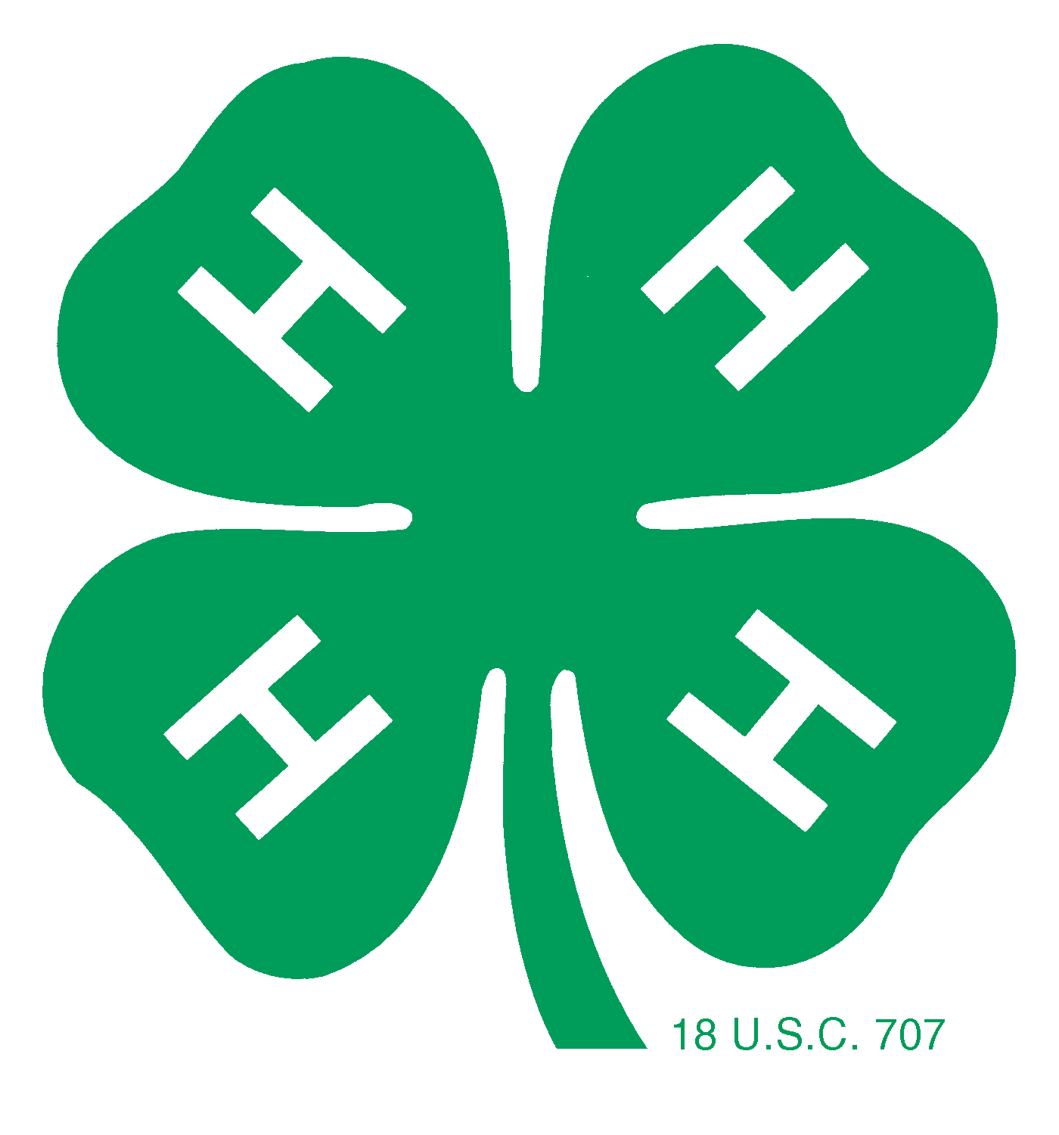
Last name:

2021 National 4-H Congress Application for Delaware

I. PROGRAM OR PROJECT ACCOMPLISHMENTS (no more than 3 pages long)

A. Project:

B. Knowledge and Skills—What I learned in this project
(List by year showing growth)

C. Size and Scope of Project

(Chart the size and scope of this project by year. Include size, costs/expenses/savings, hours spent in the project, value of project, etc.)

D. Leadership in the Project
(List by year leadership experiences related to this project)

E. Citizenship/Community Service in the Project
(List by year citizenship/community service activities related to this project)

F. Project Activities
(List or chart by year project activities—judging, demonstrations/talks/speeches, tours and workshops, exhibits, major awards, etc.)

II. LEADERSHIP EXPERIENCES (no more than 3 pages long)

A. Elected/Appointed Leadership in 4-H
(Listed by year elected and appointed leadership roles)

B. Promotional Leadership in 4-H
(List by year promotion of 4-H to non-4-H groups)

C. Volunteer Leadership in 4-H
(List Volunteer Leadership activities by year in chronological order. Include number of individuals impacted. Using the letter “L” for local club or community, “C” for county, and “S” for state. Designate the level of your involvement and participation.)

Year # Impacted Level Leadership Activity

- Leadership Experiences Outside 4-H
(List by year leadership experiences in school, church, and community. Do not include 4-H.)

III. CITIZENSHIP/COMMUNITY SERVICE (no more than 3 pages long)

- Citizenship/Community Service Activities in 4-H
(List in chronological order your citizenship/community service experiences.)
Year Activity Size/Scope of Experience Your Involvement

B. Citizenship/Community Service Outside 4-H
(List by year your involvement in citizenship/community service in your school, church, and community.)

Cooperative Extension in Agriculture and Home Economics, University of Delaware, Delaware State University, and the United States Department of Agriculture cooperating. Distributed in furtherance of Acts of Congress of May 8 and June 30, 1914. Delaware Cooperative Extension, University of Delaware. It is the policy of the Delaware Cooperative Extension System that no person shall be subjected to discrimination on the grounds of race, color, sex, disability, age or national origin.

