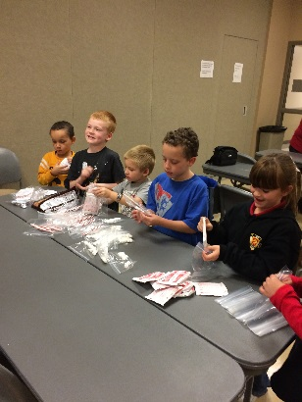
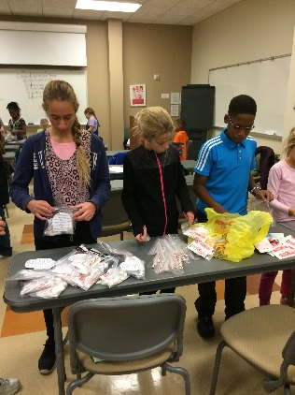
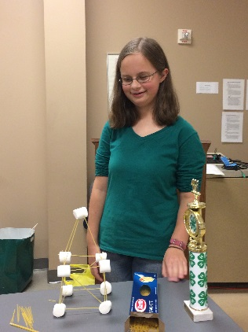
Our October meeting was a blast! Maya Merritt and Miriam Kogut led us in the 4-H pledge and the Pledge of Allegiance. Mrs. Wasgat, our club leader, talked about national 4-H week and explained what we were going to do that day. We then split up into three groups and played games. The Wallace family prepared English muffin pizzas for a snack.

This fall, Clover Quest will work with the Stockings for Soldiers organization. During our meeting we packed Snowman Soup in baggies for soldiers in need. One candy cane, one bag of hot cocoa mix, three Hershey kisses, a few small marshmallows are the ingredients for Snowman Soup. We also made Christmas cards for them.

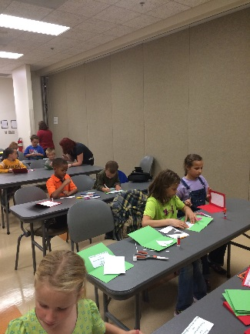
Kyle Merritt
Club Reporter

