Fiscal Year 2024 BTA Instructions

General Information:

- BTA information can be accessed on this webpage here
- FY2024 Budget Turnaround (BTA) screens must be submitted to the Budget Office by the College/Unit’s final approver by October 13, 2023.
- Anaplan BTA can be accessed here:

https://www.anaplan.com/
Follow the Login link and use the single sign-on option. Type in your UD email. You will be redirected to the University’s login screen.
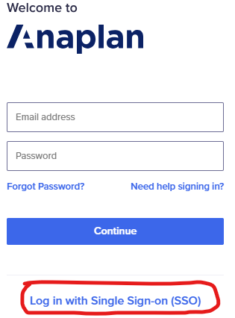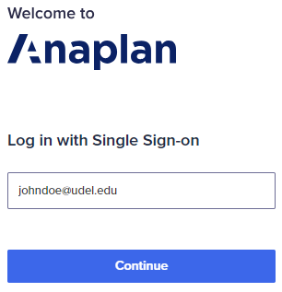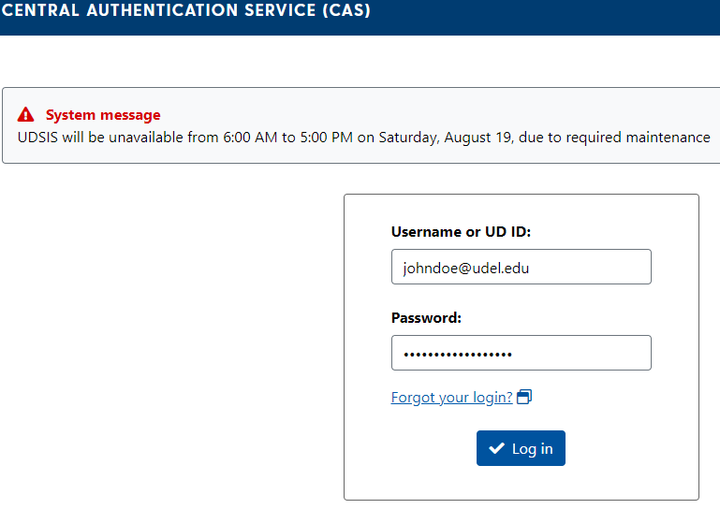

- FY2024 has been pre-populated with current fiscal year (FY2023) budget information for revenue, other labor, and OTPS.
- Actuals information is available for FY2017 through FY2022.
- FY2024 all-funds BTA budgets should be developed at the department level
  - All department level plan files, both Labor & Budget must be approved by College/Unit’s final approver
  - Revenue and OTPS (which includes transfers) budgeting are located in section 3
  - Position budgeting (Professional, Faculty, Salaried Staff) are located in section 4
  - Other wages budgeting (S-Contracts, Graduate Stipend, Wages,…) are located in section 5

- BTA load must tie by fund and by line to your distributed template. Approved deviations from budget will be captured as a projection and will be considered a variance to your budget target.
- You are responsible for managing within your individual budgets for salaries and for OTPS, including pending PO obligations. Deficits are not allowed.
- Netting of surpluses in one category (salaries and OTPS) against deficits in another category is not allowed without approval.
- Be sure to budget in a way that is reflective of activity.
- Feel free to reach out to your analyst if you need assistance/guidance with Anaplan functionality with reaching target budget by line and by fund.

General assumptions:
Tuition Increase (Resident & Non-Resident) | 5.0%
Benefit Rates | Internal External Federal AG
Faculty and Professionals - Exempt | 46.2% 39.5% 31.7%
Staff - Non Exempt | 71.3% 62.5% 42.2%
Graduate Students | 9.5% 14.4% 14.4%
Other | 8.0% 9.8% 9.8%

- Position budgeting is based on salary information as of June 2023 and includes 4% general salary adjustments.
- Position salary distribution is based on current LAM distribution as of June 2023.
- Salary Offload:
  - Salary offload is being automatically calculated through the salary distributions of position planning.
  - For units needing to budget additional salary offload at a summary level, please use 120298 (professional offload) or 121198 (faculty offload) in the Other Labor section in section 5.
  - 120298 – 121198 salary offload budgets should net to $0 across fund types.
- Refer to the PS Account Budgeting Reference List for recommended accounts to use.

If you have specific questions regarding your budgets, please email your Budget Analyst. Contact information is on our web site at: http://sites.udel.edu/budget/home/staff-and-contacts/ .

If you encounter any technical problems with the BTA Online System, please contact wf-budgetofficebta@udel.edu. We need to be aware of any problems or concerns and welcome your questions.
Basic Budget (11 fund type)
- Budget by individual departments, and purpose codes
- Non-UDBM units: FY2024 central support (1SUPPT) amount has been pre-populated based on FY24 unit templates distributed to President, Provost and EVP
- UDBM Units: FY2017 predictable base has been pre-populated.

Self-Supporting (21 fund type)
- Budget by individual departments, and purpose codes
- Individual self-supporting operations must net to $0 - use the appropriate year-end sweep account (199721 for intra-fund year-end sweep such as a 21 to a 17 reserve or 199821 for inter-fund year-end sweep such as a 21 to an 85 reserve) as a balancing tool.

Allocated (17 fund type)
- Each department has a unique budget holding purpose (eg DISA1777__)
- Includes summary historical information from individual 17 purpose codes
- Budget Office will balance using account 1MRGIN by means of an automated process during final review

Service Centers (18 fund type)
- Each department has a unique budget holding purpose (eg DBIO1877__)
- Includes summary historical information from individual 18 purpose codes
- Budget Office will balance using account 1MRGIN by means of an automated process during final review

Faculty Startup (19 fund type)
- Each department has a unique budget holding purpose (eg ENTO1977__)
- Includes summary historical information from individual 19 purpose codes
- Budget Office will balance using account 1MRGIN by means of an automated process during final review

Gifts (41 fund type)
- Each department has a unique budget holding purpose (eg MASC4177__)
- Includes summary historical information from individual 41,45 purpose codes
- Budget Office will balance using account 1MRGIN by means of an automated process during final review

Endowment (46 fund type)
- Each department has a unique budget holding purpose (eg SCHL4677__)
- Includes summary historical information from individual 46,47 purpose codes
- Budget Office will balance using account 1MRGIN by means of an automated process during final review

State Restricted (22 fund type)
- Budget by individual departments, and purpose codes
- Revenue and expense must net to $0 in each purpose code
- FY2024 State budget revenue has been pre-populated

Sponsored (31 fund type)
- Each department has a unique budget holding purpose (eg PHYS3177__ or AGRI3A77__)
- Includes summary historical information from individual 3A, 31-37,42,43 purpose codes
- Revenue and expense must net to $0 for each department

Capital (85 fund type)
- Each department has a unique budget holding purpose (eg RNOV8577__)
- Includes summary historical information from individual BLDG,85 purpose codes
- Budget Office will balance using account 1MRGIN by means of an automated process during final review

Debt Servicing (83 fund type)
- Budget by individual purpose codes
- Includes summary historical information
- Budget Office will balance using account 1MRGIN by means of an automated process during final review

